Pesach 5778/Passover 2018
Anthology of Stories and Fascinating Features

Compiled by Daniel Keren
keren18@juno.com

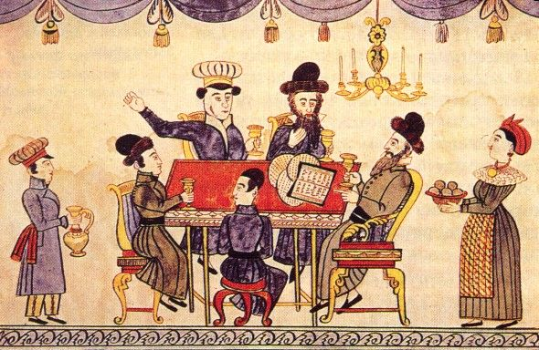

Printed in memory of Nechama bas Noach, a”h

Shabbos Stories for
Yom tov pesach 5778
Volume 9, Issue 30 15-22 Nissan 5778/ March 30 – April 7, 2018
Printed L’illuy nishmas Nechama bas R’ Noach, a”h

For a free subscription, please forward your request to keren18@juno.com

The Noda B’Yehudah and the Great Pesach Miracle in Prague

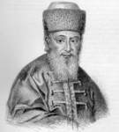

A story once occurred with the Noda B’Yehudah, Rav Yechezkel Landau, who was appointed as Rav of the Jewish community in Prague in 1755. Once he was out walking, and he noticed a small boy, a non-Jew, who was standing on a corner crying bitterly.
The Noda B’Yehudah felt compassion for him, and asked why he was crying. The child responded, “I am an orphan. My mother passed away and my father has gotten remarried to a mean woman who treats me terribly. She wakes me every morning when it’s still dark outside, and gives me a basket full of rolls to sell, and I am not allowed home until I sell all the rolls. Today, I was able to sell all the rolls, but as I was about to go home, I realized that I can’t find the money from selling the rolls, and I am afraid to go home!”
The Noda B’Yehudah inquired, “How much money did you lose?”
The boy told him the amount, and the Noda B’Yehudah whispered to himself the Pasuk from Ashrei, ‘V’Rachamav al Kol Ma’asav’, ‘And Hashem is compassionate on all His creations’ (Tehilim 145:9). He took the exact amount out of his pocket and gave it to the child.
The boy was overjoyed and thanked the nice Rabbi for being so kind to him, and the Noda B’Yehudah said that one day, he should remember that the Rabbi of the town helped him out, and the boy happily went on his way home.
Many years passed, and the Noda B’Yehudah had completely forgotten about this episode. One evening, on Chol Hamoeid Pesach, there was a knock at the door of his house.
The Noda B’Yehudah’s wife opened the door, and saw a young man standing there, a non-Jew, and he said that he wished to speak with the Rabbi privately. She was cautious and wondered what this could be about, but she knew better than to refuse him, and she invited him in.
When the man came before the Noda B’Yehudah, he asked, “Do you remember me?” The Noda B’Yehudah looked hard at the young man, but admitted, “I’m sorry, but I don’t recognize you.”
The young man said, “I am the orphan you helped many years ago. To this day, I remember how you gave me some money, and I’ve come now to return the favor. I need to tell you something very important. The Jews of Prague are about to suffer a great catastrophe.”
The Noda B’Yehudah was apprehensive and he asked what was about to occur. The man continued, “Last night, there was a meeting at my house. It was led by the priest, my stepmother, and all the bakers in Prague. They devised a plan to destroy the Jews. The bakers know that every year, on the day after Pesach, all the Jews buy bread from them. They have schemed to poison every loaf of bread that is baked after Pesach, and kill all the Jews. All the non-Jews know not to eat any bread on the day after the holiday. I am risking my life by telling you this, but I will never forget your kindness to me so many years ago.”
When the Noda B’Yehudah heard this, his face turned white. But he immediately strengthened himself, and told the young man, “I thank you from the bottom of my heart for coming to me and telling me of this terrible threat to the Jews. Your reward from Heaven will be very great, and I will never reveal that it was you who told me of this!”
For a long time, the Noda B’Yehudah tried to think of ways of how he could save the Jews, until he finally came up with a plan. He asked his Gabbai to announce that on the last day of Yom Tov after Shacharis, he would be giving a very important Drashah in the main shul in town, and that everyone— men, women and children— must come to hear him speak.
The Gabbai set out immediately to make the announcement. That morning, on the last day of Pesach, the Shul was completely packed, as everyone was curious to hear what was so urgent.
After Davening, the Noda B’Yehudah stood up to address the crowd still wrapped in his Tallis, and said:
“My friends, unfortunately, as the generations pass, the Torah becomes more and more forgotten to us. The Rabbis become less worthy and mistakes are more frequent. This year, there has been a great mistake in the calendar. The Bais Din of Prague has made an error, and Pesach should have begun one day later than it did. The day we celebrated the first day of Pesach was really Erev Pesach. Baruch Hashem we have caught this mistake, as we have almost brought the entire Jewry of Prague to eat Chometz on Pesach. Therefore, the last day of Pesach will be one day later than we thought, and I forbid everyone to eat Chometz until after Maariv tomorrow evening, since that is really when Pesach is over.”
The Jews listened in astonishment. Many had questions, but no one dared argue with the Noda B’Yehudah. If this was what their Rav decided, then they would follow his decision, and everyone accepted the ruling to extend Pesach one more day.
The next morning, all the bakers came to the Jewish part of town with wagons loaded with warm loaves of bread, as they did every year. They were sure that within a few hours they would sell all their bread to the Jews. However, the day was passing by and they hadn’t sold a single loaf of bread.
One baker asked a Jew that was walking by why no one was buying bread that day, and he responded that their Rabbi said that Pesach was extended and they couldn’t eat bread yet. The bakers were furious at this and they went to tell the priest what had happened.
The priest was quite angry and summoned for the Noda B’Yehudah to appear before him immediately. When he arrived, all the bakers were gathered there, along with the chief of police, and the priest accused the Noda B’Yehudah of trying to ruin the business of the bakers. He said by telling the Jewish people to not buy bread, it prevented the bakers from making a living, and he demanded that the Noda B’Yehudah explain himself.
Calmly, the Noda B’Yehudah said, “Your Excellency, I am happy to answer you, but first, I request that a dog be brought in to this assembly.” The priest was caught off guard by this request, but agreed to it, and a dog was brought in before them. The Noda B’Yehudah said, “I have reason to believe that the bakers are not so much interested in their livelihood, but are looking to harm the large Jewish community. I would like to examine this bread to see that it is fit to be sold.”
When the bakers heard this, they became very uneasy and frightened, but the police chief allowed the Noda B’Yehudah to continue. The Noda B’Yehudah took one of the loaves of bread from one of the wagons and fed it to the dog. Within a few moments, the dog began to look disoriented, barked, and fell dead to the ground. It was clear that the loaves of bread had been poisoned.
The Noda B’Yehudah said, “This is the bread that was attempted to be sold to the Jewish people.” The police chief immediately ordered the bakers arrested, and under questioning, they revealed that the plot was led by the priest, and all of them were punished.
When the Jews learned what had happened and how they had been saved, they praised the Noda B’Yehudah’s brilliance. The Noda B’Yehudah publicly declared what a great miracle Hashem had performed for His people, and he thanked Hashem for beginning the salvation so many years ago, by giving him the desire to help the non-Jewish orphan, whose identity he kept secret for his entire life.
Before he passed away, the Noda B’Yehudah recounted this story to his son, Rav Shmuel Landau, and he told him, “I want you to know that it was not through any special wisdom that I was able to come up with the plan to save the Jews, but it was because of a kindness that I once did for a young gentile child!”

Reprinted from the Parshas Emor 5777 email of Torah U’Tefilah: A Collection of Inspiring Insights compiled by Rabbi Yehuda Winzelberg.

Rabbi Pincus Tells How He Merited to Come Close to G-d
By Naamah Green

If there's anything in me today it's all from one rabbinic commandment, checking for Chametz, (leavening) which I did to the highest degree with self-sacrifice

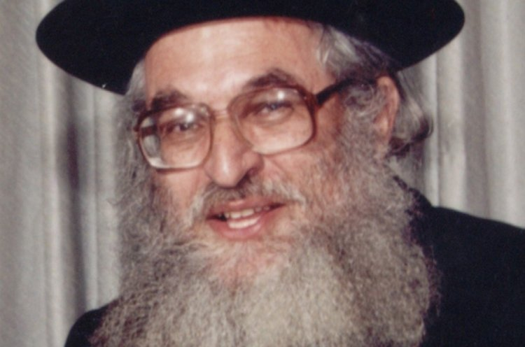
Rabbi Shimshon Dovid Pincus, zt”l

Rabbi Shimshon Pincus of blessed memory passed away 15 years ago and he was well-known for the love of God that burned in his heart. This fire characterized all his speeches in which he would kindle the hearts of Jews to learn Torah and serve G-d. This love burned even brighter every time he would do any mitzvah whether between man and man or between man and G-d. If he accepted something upon himself he went all the way with it and didn't spare any effort to fulfill it properly.
For many years people wanted to learn the secret how he merited the great heights that he reached in serving G-d? Where did he start from and how did a young American boy grow up to be an elevated person with real closeness to G-d?
Rabbi Pincus in his humility would never talk about himself and evaded the question. In a rare moment he explained the following to his family and friends. He actually wrote this story in an introduction to his Haggadah of Passover Tiferet Shimshon.
When I was a student in the Brisk Yeshiva I lived in an apartment with a few roommates. Since I was from out of Israel and I did not return home for Passover the situation was that I had to check my own apartment by myself and I was responsible for the whole apartment.
The apartment was big, old and neglected so checking it for Chametz went late into the night. I worked for room to room it took great effort moving obstacles preventing me from checking. There were many other things that made the checking difficult. Finally I finished checking the apartment close to midnight. I collapsed on the chair feeling worn-out but full of satisfaction.
Just then another thought disturbed my rest. I remembered that there's a joint attic that belongs to the whole building and in reality everyone was responsible to check it. But I knew that if I don't check it now, no one else is going to do it.
Inside my heart a battle was raging. On one hand I was worn out and tired and I knew that I did above and beyond my obligation. On the other hand I knew that these thoughts were based on physical tiredness and really the best thing for me to do would be to go up and check the attic.
After a few minutes of internal debate I decided I'm not giving in. I decided to do the Mitzvah totally in the most complete manner with self-sacrifice. I climbed up with the last of my strength into the attic. When I open the old door and turned on the light I was shocked by what I saw. It was obvious that no one cleaned here for years if at all! The floor was covered with a thick layer of dust and in every corner there were items strewn around.
The rabbi continued and repeated a law that he remembered when he saw the attic; “Every man has to clean up his room before checking.” That means even before the tedious job of checking he would have the task of cleaning it up.
The tiredness that overcame all my bones almost made me give up but I remembered then that I made up my mind to do this Mitzvah with self-sacrifice no matter what. So I made believe I didn't just finish a few hours of work in my own apartment. I grabbed buckets of water and I started working.

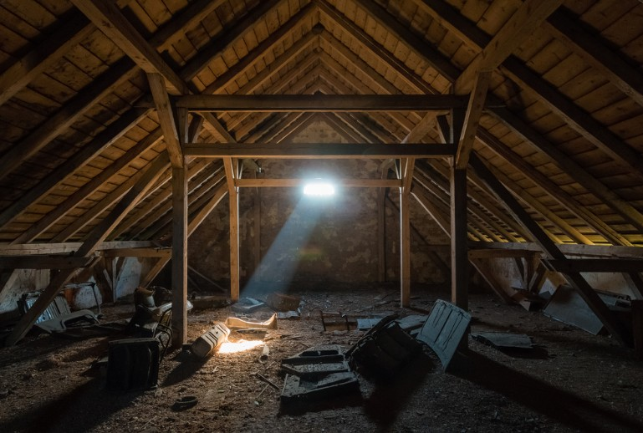

A stranger coming up to the attic at that time would have been shocked by what he saw; a young American student covered with mud and plaster cleaning a place that was almost never cleaned and probably almost no man ever set foot there. All this is taking place way after midnight the night before Passover.
It was close to dawn when I finished checking the entire attic for Chametz. My whole body was shaking from the effort and the great tiredness that came over me. When I finished, it was already sunrise. In the morning after praying I hoped to rest a bit but the Mitzvoth of the day like burning the Chametz made me forgo my rest even though I was really tired.
Right before the evening prayers on the Seder night I thought to myself sadly: “What kind of Seder can I hope for if I am so wiped out? My tiredness will overcome me! Who knows if I'll be able to drink the four cups of wine at all?” I started praying with mixed feelings but as soon as I started praying I forgot everything. A spirit of holiness came to lift me up and a sweet feeling that I never felt before rested upon me.
I began my Seder night with those elevated feelings and to my wonderment I didn't feel tired at all. Quite the opposite I was so alert that I did not want to waste even one moment of the holy night. I read the Haggadah with an elevated spirit and my heart was overflowing with happiness. The words of the Haggadah weresweet on my lips.
I fulfilled all the mitzvoth of the night such as eating matzo, bitter herb and drinking 4 cups of wine feeling elated. I wasn't tired at all and I felt with my whole being that I am prepared to sacrifice myself to keep the mitzvoth.
I became a different person. I felt true closeness to G-d and a great light enveloped me the whole Seder night until after midnight. To my great wonder, even after the Seder was completed, I couldn't fall asleep. I stayed up the whole night and went over the story of leaving Egypt until the morning. I was surprised to find that this elevated spirit acompanied me from the Seder night till the end of the holiday. I took advantage of the opportunity to expend great effort in prayer and Torah learning. You can say that on that Passover, I dealt with nothing but closeness to G-d.
In that year, the seventh day of Passover was a Friday and during the last afternoon prayer of Passover, tears came to my eyes. I feared very much that the spirit of holiness that rested upon me all of Passover would weaken and leave me when the Sabbath came. I strengthened myself with the thought that Shabbat is even holier than the holiday. I decided to keep on striving to go higher spiritually. I hoped for continued assistance from on high. Indeed I felt for the first time the very sweet taste of the Holy Shabbat and for the first time I understood the essence of its holiness. From that moment on I started rising to higher levels in my Divine service.
Rabbi Shimshon concludes his secret saying: If there's anything in me today, it all came from that one rabbinical Mitzvah; the Mitzvah of checking for Chametz that I grabbed onto and fulfilled with self-sacrifice.

Reprinted from the Pesach 5777 email of Hidabroot.

Describe a Person Properly
By Rabbi Sholom D. Avtzon

Since this upcoming Wednesday is Chof-Beis (the 22nd) of Shevat, the Yahrzeit of Rebbetzin Chaya Mushka, I chose to relate the following vignette/snippet of her life, with the hope that we will learn from it. As the Rebbe continuously said after her petirah, Vihachai yieten el libo - and the living shall take to heart.
Reb Berel Raskin sheyichye, would supply fish for the Rebbe’s house. One year on Erev Pesach, he began enumerating to the Rebbetzin the hiddurim he did and how he scrupulously prepared their fish for Pesach.
(He mentioned to me two of the hiddurim that he was careful with, which he thought the Rebbe would want.) Instead of packing the fish in plastic bags, he placed them in glass jars as well as using a special set of knives and utensils exclusively for their fish order.
The Rebbetzin thanked him and said, “Mr. Raskin, zei nisht azoi nerveiz, mein mahn fahrluzt zich oif dir – Mr. Raskin, don’t be so nervous, my husband trusts you. [i.e., You don’t have to prove it, by specifying everything you did].”
She then said, “It is a proper thing that you cleaned the store and machinery for Pesach. I heard that other storekeepers say, ‘My store is Kosher L’Pesach year round and there is no need to clean it before Pesach.’ That is not how we were raised. I remember as a youngster, how my grandfather [the Rebbe Rashab], my father [the Frierdiker Rebbe], and everyone in the house, would take out the wooden boards to the courtyard and we scrubbed and scoured it, so that it should be cleaned for Pesach, even boards that definitely had no contact with Chometz throughout the year.”

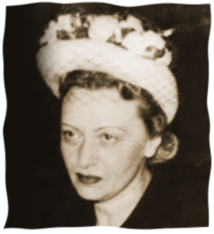
Rebbetzin Chaya Mushka, a”h

The Rebbetzin then said, “If you have a few moments I will mention another difference between then and now.
When I was growing up in Lubavitch, the way a person was described as was, “Der yid, di vasser truger – the Jew who brings water from the well, der yid di shneider – the Jew the tailor, der Yid di katzov – the Jew who is a butcher, etc.
“But here in America, they are called by their profession or livelihood, one is called the baker, another one is the butcher, grocer, tailor or taxi driver.”
Compiler’s note: I believe she was saying that the proper approach is to recognize that his essence is that he is a fellow Jew, whose source of livelihood may be one thing or another, but that is not his essence. His essence is Der Yid.
Rabbi Avtzon is a veteran mechanech and the author of numerous books on the Rebbeim [of Lubavitch] and their chassidim. He is available to farbreng in your community and can be contacted at avtzonbooks@gmail.com

Reprinted from the February 1, 2018 Weekly Story email of Rabbi Avtzon.
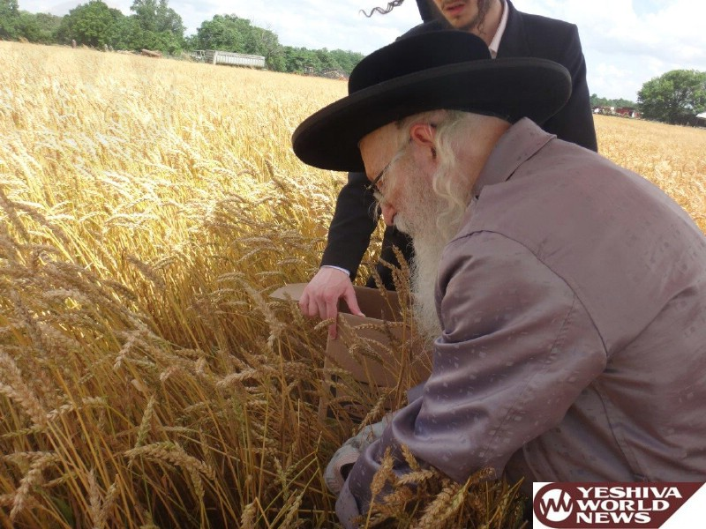
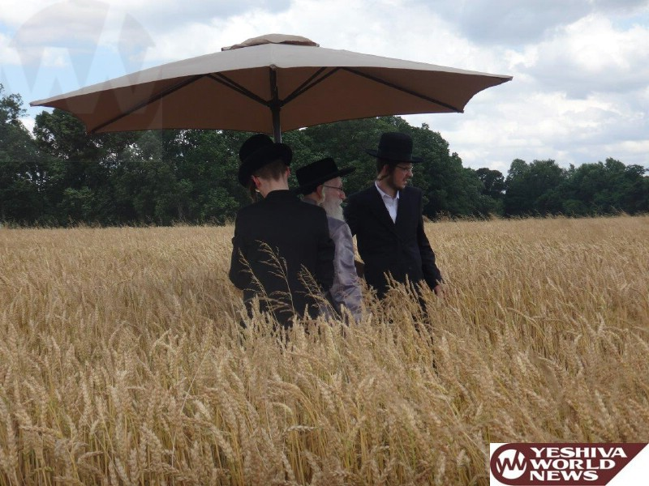

Serdaheli Rov Supervising the cutting of wheat for matzos (Photos by JDN)
Reprinted from the June 21, 2017 website of Yeshiva World News.
Chareidi Family Fined
For Singing Too Loudly
At Their Pesach Seder

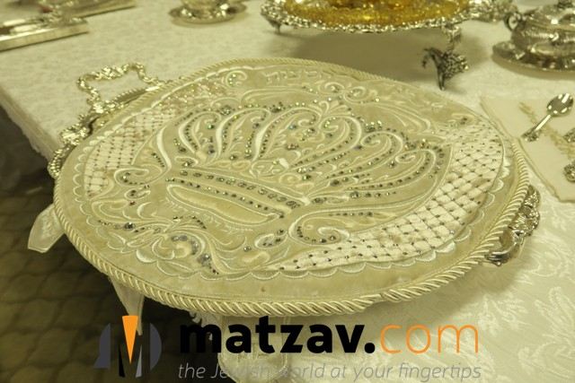

A Bnei Brak family was fined $95 on Pesach after neighbors complained about their singing.
“We held the seder the same as every Jewish home,” Rav Chaim Shaul Rosenberg told Chadrei Chareidim. “My neighbor, a religious Jew, was apparently bothered by our singing and cut off our electricity via the lobby power box. We still had light from the candles in the living room and from an adjacent room and continued the yom tov meal. But a few minutes later, police arrived and demanded that we stop the noise. I told the police officer, ‘We have already begun the meal and will try to finish soon and be quiet.'”
Police returned soon afterwards and fined the family $95.
MK Yisroel Eichler of UTJ wrote to Environmental Minister Ze’ev Elkin and demanded an immediate cancellation of the fine. He noted that it was just as well that Israeli police officers were not around when Rabi Akiva and the chachomim celebrated a seder all night in Bnei Brak or they too would have been fined.

Reprinted from the May 3, 2017 website of Matzav.com
The Special Cup of Elijah
By Rabbi Tuvia Bolton

Once there was a very rich Jew who we will call Yitzchak, who was a follower of the great Tzadik and holy genius Rebbe Yisroel of Ruzhin. Yitzchak was known for his warm heart and open hand. He gave a lot of charity. Every day his home was filled with the poor and hungry coming for a handout, a meal or just a place to rest for a while. But where he really shined was on Pesach (Passover).

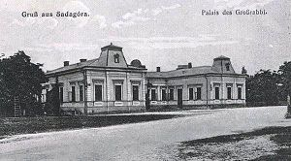
Partial view of the palace of the Ruzhiner Rebbe in Sadigura.

Every year more than a hundred guests graced his table. People came from far and wide to partake of the joyous celebration of remembering the miracles G-d did thousands of years ago and hoping for even greater ones.
But, as we all know, there is a wheel of fortune in the world and so it was for our hero. It’s not important how but suddenly Yitzchak's fortune dwindled until within months he lost everything and found himself a pauper with almost nothing to eat.
In order to pay his creditors, he was forced to sell his businesses, his properties and even his furniture. His wife sold her jewelry and everything of value in the house including their precious candle sticks until his house was a virtual shell¦ and it would only be a matter of time till it would have to be sold as well.
But there was one thing that his wife refused to part with. She had sold all her fine dresses and ornaments, even her family heirlooms but she refused to part with the Kos Shel Eliahu; the cup we fill with wine for Elijah the Prophet (who was taken in a wind to heaven some 2,800 years ago and supposedly visits every Passover Seder) at the end of the Passover Seder.
It really made no sense. The cup was made of gold and would surely have brought a good sum. Every so often her husband would add a jewel or golden inscription to it so it was worth a lot of money. But she refused to let it go. "It's our only hope." She said. "Elijah will announce Moshiach and Moshiach is our only hope."
Yitzchak was in no mood to argue with her. If poverty didn't convince her to sell it he surely wouldn't. And deep down he knew, or at least hoped, that she was right.
But the morning before the Pesach Seder their house was barren. Somehow they scraped together enough money for a bottle of wine, a few Matzot, some potatoes and a small piece of fish. But beside that and a small table, two chairs. and their cup for Elisha, they had nothing.
So with only hope (which was waning) and an empty stomach (which was waxing) he told his wife he was going to the synagogue that morning and would return only that evening for what was sure to be a lonely, quiet, shadow-of-the-past Seder.
He sat alone in the Shul (Synagogue) and did his best not to weep. But it wasn't easy. The thought of days gone by and of the dismal future; maybe next week he wouldn't even have his house, haunted him.
Close to evening he went to the Mikva, washed up, immersed himself, changed his clothes and tried to keep a smile on his face and a song on his lips as returned to the Shul, prayed with the congregation and slowly walked home alone.
But as he approached and saw his house in the distance his forced smile faded and he fell silent in awe. His house was.. ablaze with light! From inside¦ it was filled with people!
He thought that perhaps he had lost his mind. He shook his head as though trying to wake up. He rubbed his eyes and held his temples in disbelief and approached.
He opened the door and it was like a dream. His huge front room was filled with guests, maybe a hundred of them, all joyously, handsomely dressed and busy arranging their places at a huge, long, decorated table. Lights and candles were shining everywhere! He looked at his wife. She was dressed like a queen! She gazed back at him, her eyes sparkling with sweet tears of joy as she raised her arms and announced,
"My husband! Rav Yitzchak!!"
Everyone stood and applauded and poor Yitzchak broke down in tears and swooned. He would have fallen on his knees and raised his hands in thanks to G-d but it just didn't seem to be the right thing to do so he wiped his eyes, held up his hands for silence and yelled, "Good Yom Tov (holiday) everyone!! Thank G-d for everything!!" and everyone answered "Good Yom Tov!!" and resumed finding and arranging their places.
His wife approached, smiling from ear to ear, and explained.
"Just after you left this morning, a carriage pulled up in front of the house and an important looking Jew got out and knocked at our door. He said that many years ago he had been at our Passover Seder and never forgot it. He said that his carriage happened to break down here yesterday and he just got it fixed. He wanted to know if it was all right if he spent the Passover with us again.
“But when I told him that we didn't have enough food for guests he insisted that money was no problem and he gave me five thousand guilder! Five thousand!!
“"I tried to refuse. I told him it was a thousand times what we needed. But he insisted. In fact, he even took the money back and gave it to his servants to buy food and hire workers to prepare it. He even bought new furniture and tapestries! It's unbelievable! In just hours the food and pots and everything were delivered, the stove was burning, the house was busy and people were coming from all over to help. It's a miracle! And soon he'll be here. He told me not to wait for him, that he would be a bit late but I'm sure he'll be here any moment and we can thank him."
That Seder night was probably the best and happiest that Yitzchak and his wife ever had in their lives and, sure enough, when the meal was almost finished, their rich benefactor appeared, apologized for being late, hurriedly found a seat, and before anyone knew it finished his Seder quickly and quietly and approached them.
They thanked him profusely to which he replied. "I understand that you've been having a hard time financially. Well, I bless you with greater riches than before." And with those words, he turned on his heels and left.
Sure enough, several of the guests that night were businessmen and as soon as the holiday ended, eight days later, Yitzchak was back in business and in just a few weeks he was making money and giving charity like never before.
Months later Yitzchak visited his Rebbe, told him the entire story and gave a him a huge donation. The Rebbe put his head down for a minute, lifted it and said.
"That rich man was Elijah the Prophet. You merited seeing him once and your wife merited to see him twice! It was all in the merit of that cup and her simple faith. She was right! Your only hope was Elijah."

Reprinted from the Parshas Shemini 5777 email of Yeshiva Ohr Tmimim in Kfar Chabad, Israel. Adapted from Sichot HaShavua #1162.

Don’t Make Passover
Too Easy
By Jeffrey Yoskowitz

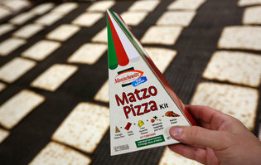
Manischewitz unveiled triangular matzo this year.CreditSeth Wenig/Associated Press

Eleven years ago, I stayed with a Jewish family in Zimbabwe for Passover. There was no supermarket with kosher holiday foods nearby, so nearly every dish was made from scratch, from the chopped herring down to the stuffed grape leaves. My hosts had roots in both Lithuania and the Greek island of Rhodes, and each dish was rooted in the family’s distinct story; a few even featured the avocados growing in the backyard.
I spent the next Passover back in the United States. For the seders, I enjoyed some of my family classics, like potato kugel, brisket and matzo ball soup. I spent the rest of that holiday, however, eating a considerable amount of packaged “kosher for Passover” foods, such as matzo and jam, special cereal and other snacks. I longed for my meals in Zimbabwe — though I don’t doubt that my hosts would have appreciated access to the kosher aisle of an American supermarket to ease the burden of navigating the very elaborate and specific eating guidelines of Passover.
For a holiday all about freedom, Passover dietary restrictions — no bread or leavened goods and, traditionally, for Ashkenazi Jews, no legumes, rice or corn — can be quite taxing. Despite this complex set of rules and customs, a growing number of processed foods that meet these age-old Passover restrictions can now be found in supermarkets across this country. It’s increasingly possible to eat the same way on Passover as on any other day of the year, perhaps with a larger dose of tapioca and potato starch.
Yet embracing the holiday’s tedious dietary restrictions, not working around them, is critical to appreciating this holiday on a deeper level. And to eating well.
Generations ago, Passover preparations did not start at the supermarket. Jews in Baghdad spent months making wine and date syrup, pickling vegetables and baking matzos. Ashkenazi Jews in Eastern Europe rendered goose and chicken fat and set it aside in early winter.
In the United States, mass-produced items began replacing homemade Jewish dishes in the middle of the 20th century (think gefilte fish from a jar, latkes and matzo balls from a box). Today the kosher offerings in supermarkets include a wide array of Passover products, from frozen gluten-free pizzas to cakes, sriracha mayonnaise and ice cream cones.
The number of unique Passover food items has more than doubled since 2011, to 52,000 from 23,000, according to Menachem Lubinsky, editor in chief of the trade newspaper Kosher Today. The holiday is the cornerstone of a multibillion-dollar industry. While corporate giants like Coca-Cola make Passover versions of their products, most are produced by specifically Jewish brands, according to Roger Horowitz, author of “Kosher USA.” About 40 percent of sales in the kosher food market are for Passover alone.
In so many ways, mass-produced kosher foods have made the holiday far less onerous. Families that once kept live fish in their bathtubs the week leading up to the holiday to make fresh gefilte fish no longer needed to turn bathrooms into aquariums. But what have we lost?
What defined Passover cooking around the world were the flavors of springtime, the ingenious substitutions for basic ingredients developed by clever cooks and the reliance on pure, simple ingredients. In northern climates, there isn’t a bounty of produce in early spring, so Jews relied on pickled foods they stored through winter, and foraged for wild spring greens, mushrooms and roots like wild horseradish. Sorrel soup, known as schav, is a traditional Eastern European Passover specialty.
Jewish cooks got creative. My grandmother made pancakes and “bread” rolls out of crushed matzo meal, which seemed like alchemy to me as a child. My great-aunt Yetta added a touch of potato starch to eggs, which she’d fry into a thin crepe, then either shred it into “noodles” or wrap it around farmers cheese for blintzes.
Dessert is a real miracle of Passover. Meringues, macaroons and chocolate are so prevalent on Passover because of the simplicity of their ingredients. The chef Yotam Ottolenghi writes that unleavened cakes are the “mother of great invention.” Ground nuts replaced flour; citrus sugar syrup or amaretto prevented it all from drying out.
In many ways, how we eat for the week of Passover is a reflection of ourselves, and it’s no surprise that the Passover table looks more like a typical American table. The fact that an entire aisle is dedicated to mass-produced Passover foods in many supermarkets signals the ways in which the Jewish community has been accepted into American life.
But that acceptance can be precarious. The challenge of making a meal with so many restrictions serves as a reminder of where Jews have come from and the importance of retelling the story of a time when they were not so fortunate.
This Passover, I suggest leaning into the limitations, rather than working your way around them. Embrace a restricted pantry and track down old recipes to make unique Jewish holiday dishes like matzo brei and dried fruit compote. Head to the farmers market to get a taste of the early spring greens and foraged foods.
As you grate potatoes for your kugel or chop walnuts for haroseth, remember that these foods tell the story of an identity in formation. And as you shape your matzo balls, reflect on the years of struggle for the privilege to be able to buy Passover pasta and matzo granola in a mainstream American supermarket.

Jeffrey Yoskowitz is a co-author of “The Gefilte Manifesto: New Recipes for Old World Jewish Foods” and co-owner of the Gefilteria, a purveyor of Ashkenazi cuisine.

Reprinted from the April 8, 2017 website of The New York Times. A version of this op-ed appears in print on April 9, 2017, on Page SR5 of the New York edition with the headline: Skip the Passover Pizza.

No Greater, No Lesser
Defying the Soviet Regime to Defend Jewish Integrity in Baking Matzas

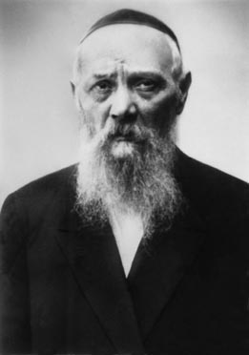

"Moses, our teacher, is very, very great. But he is no greater than a Jew. At the same time, the simplest Jew is very simple, but he is no lesser than a Jew."
This was a favorite saying of Rabbi Levi Yitzchak Schneerson, Jewish leader, scholar, Kabalist, and father of the Rebbe, whose anniversary of passing occurs this week.
As certain as Rabbi Levi Yitzchak was that every Jew is equal in G-d's eyes, that is how fearless he was in defending every Jew and the Torah's laws in the face of government or other intimidation.
To illustrate: It was in the early years of the Soviet regime, when all commerce and business throughout the country had already been nationalized.
All of the mills and matza bakeries were run by the government. When it was time to ship the wheat for the matza and they needed a certifying rabbi, the government asked Rabbi Levi Yitzchak as they had in previous years.
However, that year, the government representatives explained that if any of flour would not be allowed because it did not meet his approval, there would be a monetary loss to the government and it would be interpreted as a declaration of war against the state.
Rabbi Levi Yitzchak was unbending. If they allowed him to hire people whose instructions would be strictly obeyed, he would certify the flour. And if not, he would not comply. And not only that, he would make sure to publicize that it was not under his supervision.
The government representatives threatened Rabbi Levi Yitzchak who declared that he was ready to travel to Moscow and meet with the president of the Soviet Union to discuss the matter. But he absolutely refused to put his name on something that did not deserve it, as it was against Jewish law and against G-d.
The matter was referred to the highest authorities. In the end, the government representatives were told that everything Rabbi Levi Yitzchak said must be followed to the letter.
And that is what happened that year, and the next year and the next. In all of the government-sponsored matza bakeries throughout the Soviet Union, only the flour approved by Rabbi Levi Yitzchak was used.
In retelling this story about his father, the Rebbe [Rabbi Menachem Mendel Schneerson, zt”l] shared the life-lesson that can be gained from it. "When a Jew stands firm and declares that he cannot act contrary to G-d's command, nor is he willing to do anything against Jewish law, he will ultimately succeed.
"Of course, not everyone can demonstrate such strength. But it is also true that not everyone must oppose an entire government ruling over 200 million people. All that most of us need to do is to take a stand against our own evil inclination."
May we all have the strength to take a stand wherever and whenever we need to!

Reprinted from the Parshat Va’eschanan 5776 edition of “L’Chaim Weekly” published by the Lubavitch Youth Organization of Brooklyn, NY.

Story #960

A Passover Seder Debate
From the desk of Yerachmiel Tilles
editor@ascentofsafed.com

It was the day before Passover 5516 (1756), and as on all Jewish holidays, many of the followers of the holy Baal Shem Tov came to Mezibush to spend Passover with their Rebbe. It was always an uplifting, almost magical experience to be in the presence of the Baal Shem Tov, especially at the time of a Jewish holiday. But, on this Passover, the chasidim were upset because they could sense that something was seriously bothering the Besht (Baal Shem Tov). He was not in his usual buoyant spirits.
After the search for chametz on the night before the Seder, the Baal Shem Tov told ten of his closest disciples to say Tikun Chatzot (the midnight prayer to commemorate the destruction of the Temple) with great concentration. While saying this prayer, Reb Tzvi (the scribe of the Besht) came running and yelled, "Lord of the Universe, the Rebbe fainted and fell onto the floor of his study." Everyone was upset, but no one would dare go into the study and disturb the Besht.
The next morning before the Passover Seder, the Baal Shem Tov prayed the morning prayers in what seemed to them a despondent mood. When he finished his prayers, he expounded about 'Trust in G-d': "True and complete faith in G-d can only occur when a person can't see any way to overcome his problem. When, at that very moment, the person believes without a doubt that G-d will save him from his problem, and most importantly, the person shows this trust and faith in G-d by being b'simcha (having a joyful attitude), this joy itself indicates that the person has no doubt that he will soon, with G-d's help, overcome his problem."
As soon as the Besht finished this discourse, his mood noticeably changed. He seemed more at ease. The followers whispered among themselves, "The change in the Rebbe's mood is not because of a change in the spiritual decree about which he is no doubt concerned. No," everyone agreed, "the change in the Rebbe will change the Heavenly decree, G-d help us."
In the afternoon of that same day, when the time came to bake the matzos (matzos made after midday before the Seder are considered the most precious), the Baal Shem Tov immersed in themikveh (ritual pool) before coming to the bakery. His mood had improved even more and he actually seemed to be happy.
That night, in the synagogue of the Baal Shem Tov, the special evening prayers for Passover were chanted with great enthusiasm. After the prayers, his close disciples who were invited to theSeder of the Besht sat around the Seder table eagerly awaiting to hear his insights on the Haggadah. But this Passover night was different because the Besht did not expound on the deep mystical meanings of the Haggadah. Instead, to the disappointment of his guests, he just quietly read the text.
Near the end of the Seder, the Baal Shem Tov closed his eyes. The disciples looked at each other, "Is he in a state of deep meditation or did he 'almost' fall asleep." The room was silent. Suddenly, the Besht started laughing so hard that he could barely sit still in his chair.
"Mazel Tov!" he exclaimed, "Thanks to G-d who has chosen the Torah, Moses our teacher and Israel. You should know that even the simplest Jew can change a Heavenly edict."
The disciples sat speechless as he began to explain.
"Yesterday morning, a terrible edict was decreed in Heaven against the Jews of a nearby village. The non-Jewish peasants in that village were planning to attack the Jews on the first night of Passover.
"I prayed with all my strength, and I even had you help me. But we couldn't overcome the Heavenly decree. I finally gave up and put my trust in G-d that the decree would be rescinded. Right then I started to feel joyful.
"When we sat down to the Seder, the hour for the execution of the decree had arrived. I didn't see any hope for those Jews living in that village. But in a single instant, thank G-d, everything changed.
"During this time, a childless couple among my followers living in the village where the decree was to be executed was sitting at their Seder Table. Although they are simple, unlearned Jews, they are exceptionally kind, devout and full of good deeds. When they reached the section of the Haggadah about the Egyptians throwing the new born baby boys into the Nile, the wife started to cry. Her husband tried to comfort her, 'My dear wife, don't be sad, after all the Jewish people were finally taken out of Egypt.'
"The wife spoke back, 'If G-d had blessed me with a son, I would have protected him and not let anyone hurt him. And I certainly would not have let anyone treat my son the way G-d let us be treated by the Egyptians.'
"The husband defended G-d saying, 'The L-rd is righteous in all that He does, it's only that we can't always see or understand why it is good for us.'
"But the wife answered back, 'Why isn't G-d more compassionate? How could He have treated us like that? Even if we do sin, we are still His children.'
"And so the argument went back and forth as they worked their way through the Haggadah. Meanwhile, the case against the Jews of their village was being argued before the Heavenly Court. The defending angels were more persuasive when the wife presented her arguments and the accusing angels were more persuasive when the husband presented his rebuttals. I really couldn't tell what the outcome would be.
"Finally, after completing the fourth cup of wine near the end of the Seder, the husband couldn't think of another answer to his wife's arguments against G-d's behavior. So he conceded, 'My wife, you're right. G-d should have treated his children better.'
"They started to laugh, got up and began to dance around the Seder table. And at that very moment, the decree in Heaven against the Jews of their village was annulled," the Besht concluded.
The disciples were mesmerized with the story. Then, the Besht told them to place their hands on the shoulders of the person sitting on either side. When the Baal Shem Tov completed the circle by placing his hands on the shoulders of the person sitting on either side of him, the disciples all saw a vision of the husband and wife dancing together around their Seder table celebrating the liberation of the Jewish people from Egypt.
The Baal Shem Tov said with a little chuckle, "They should only know that they are also celebrating the liberation of the Jewish people of their own village."

Source: Adapted by Yerachmiel Tilles from the redition of Tzvi-Meir HaCohen (Howard M. Cohn, Patent Attorney) of a story in Seeker of Slumbering Souls: Stories of the Baal Shem Tov, Volume 1 (Chai Books).
Biographical note: Rabbi Yisrael ben Eliezer (18 Elul 1698-6 Sivan 1760), the Baal Shem Tov ["master of the good Name"], a unique and seminal figure in Jewish history, revealed the Chassidic movement and his own identity as an exceptionally holy person, on his 36th birthday, 18 Elul 1734. He wrote no books, although many claim to contain his teachings. One available in English is the excellent annotated translation of Tzava'at Harivash, published by Kehos.

Reprinted from the archives of KabbalahOnline.org, a division of the Ascent Institute of Safed, Israel.
Passover Overreaction
By Emuna Braverman

If I spend the preparation time yelling at my children, am I really getting rid of the chametz?

One of my children (who shall remain nameless but knows perfectly well who she is!) upended a large tray of cookies onto the living room couch the other night. “Pesach is coming!” I shrieked.
“But the room isn't yet cleaned for chametz,” she pleaded. “What's the big deal?”
I polled my friends. Did I overreact?
“I would have been over the edge if it happened in October,” said one. “Definitely nervous breakdown material,” nodded another.
I calmed down but erupted again when the same child (I hope you're reading this!) sat eating crackers (very crumbly ones I might add) in the aforementioned living room.
And yet I know it's irrational. The house will get cleaned -- even if I have to do it myself! (Oh yeah, I do! No wonder I'm frustrated…) The crumbs will be swept or brushed or vacuumed away. We will, please God, sit down to a delicious meal on Passover night in a chametz-free environment.
The only question is: What state I will be in when we get there (and along the way)?
The real couch is our character; the real crumbs, our negative traits.
If I spend the preparation time yelling at my children, am I really getting rid of the chametz? We are taught that the chametz/leaven symbolizes ego. The real clean-up is a spiritual one. The real couch is our character; the real crumbs, our negative traits.
If I am on edge and testy with everyone as we get ready for the holiday, then I've missed the point. If our home is physically clean but spiritually a mess, then my preparations are incomplete. If I don't sit down to the Seder with a smile on my (tired) face, then my home is still full ofchametz.
So I'm regrouping. I'm taking a deep breath. I'm taking many deep breaths (I'm hyperventilating!) I'm focusing on the atmosphere I want to create and the person I'd like to be.
I may still get frustrated (who put the Cheerios in my eyeglass case?!). I may be a little tense (What cabinet did that cup come out of?), but I'm trying to be better. I'm really trying to get rid of my chametz. I haven't succeeded yet but I'm asking the A-mighty for help. Maybe this is the year I will truly become free.

Reprinted from Aish.com Originally published on March 21, 2010.

A Pesach Miracle in Alsace
By Rabbi Tuvia Bolton

The year was 1848. The spirit of revolution in Europe brought confusion and disorder everywhere and the thin distinction between freedom fighters and bandits dissolved. Gangs of armed hoodlums, hungry for blood and loot were on highways everywhere robbing and pillaging and the ones that especially suffered were who else? - the Jews.
They were rarely armed, were never protected by the police or army and were considered by all the warring sides as siding with the enemy.
Passover was approaching but in the Jewish quarter in the area of Alsace there was fear and weeping.
It seems that a caravan of Jewish wagons, on their way there to spend the Holiday at home with their families had been robbed by an army of two hundred bandits who first stole all their belongings and were about to kill them all until they discovered the wine.
It seems that as well as money their wagons were laden with all the necessities of Passover: presents for the family, food and matzoth for the festive meal and, most important, fifty barrels of fine wine for the ceremonial cups of redemption.
When the bandits realized what a treasure they had stumbled upon they went berserk and immediately began fulfilling their life's goal; getting drunk! And as soon as the wine started taking effect they decided to have some fun, untied their prisoners and scoffing out loud told them to run home saying,
"In any case we're going to take over your entire miserable town tomorrow and you don't stand a chance. So go kiss your families good bye!! Ha Ha Haaaa!!"
So when the Jews made it to their homes the next morning and told everyone what had happened there was mourning and wailing. Passover would begin in nine hours, Jews would be celebrating the Holiday of Freedom all over the world - but not them. Their lives were in danger!
The first instinct was to runâ€¦ but where? The bandits were sure to catch them. Maybe they could pay them off; somehow appease them? But that was also out of the question, their intention was to steal everything. Indeed, the Rabbi pointed out that trying to appease them would only show weakness.
They decided that the only chance they had was to fight.
The richest man in the community, a born leader by the name of Shmuel Leib took command.
"Listen, everyone run home, hide your valuables, arm yourselves with anything that can be used as a weapon and come to my house with your families. If we're together we have a chance! Bring knives, meat cleavers, anything metal. My house is the second one after the gate and they have to pass it to get into the town. We'll put the women and children in the basement and give them a fight they'll never forget."
"What about the first house? The house of Aaron the butcher?" Someone asked.
"I'm sure that my house will attract them." Shmuel answered. "His is first, but it's small and what they are after is money. When they see no one is there they will pass it up. Here is where they will attack first. I'm sure of it! And here we'll surprise them. The butcher and his family will come to my house with everyone else.”
In no time all the men ran home and just hours before nightfall they were all gathered in Shmuel's mansion making plans and preparing their makeshift weapons. They even sent out a few boys dressed in dark clothes to spy on the enemy and report back.
The sun set and the eerie full moon made the dark empty streets glow ominously. The air in Shmuel's house was tense with fear. Their kitchen knives were no match against swords and battle axes. They sat in darkness and waited. As soon as the enemy came near they would attack from all the doors of the house and hope for a miracle.
Suddenly they heard a pre-arranged knock on the door and opened up; it was the boys out of breath.
"They're coming! They're almost at the gate. But Aaron the butcher, he's in his home - he said he’s not coming here!"
"What do you mean?" Shmuel whispered as loud as possible "He isn't coming?! What's he doing at home? Has he gone crazy!? He doesn't stand a chance!"
"He said that tonight is Pesach" the boy answered. "He said it's the night when G-d protects us and that he's not afraid. So he's going to make the Passover 'Seder' and trust in HaShem!"
Someone in Shmuel's house lifted up a window shade and sure enoughâ€¦ there was Aaron the butcher's house lit up as bright as a torch.
"They're coming!" Another of the boys entered and whispered almost hysterically.
The band of thieves silently entered the gate of the Jewish quarter like a pack of human wolves with their weapons in hand and headed toward the lights coming from Aaron's home, overjoyed that the Jews seemingly weren't even expecting them!
Their leader told them to wait and signaled two of his men to accompany him to the back of the house where he told them to lift him so he could see if it was a trap.
Two of his men lifted him and he peaked into the window.
He was shocked! It was the butcher! He recognized him! The butcher bought a cow from him once. But now he looked like a king! And his wife like a queen! And the children like little angels! The entire house was brightly lit and the family was sitting around a festive table with silver vessels on it glistening in the light of the candles and they were smiling and â€¦. Singing! He couldn't believe his eyes! The entire family was glowing!"
He motioned for his men to let him down and hastened back to the impatient group who were straining like hungry dogs at the leash for the word to attack.
"We're getting out of here! NOW!" He said in a loud urgent voice. "These Jews are doing witchcraft! magicians!! I knew it!! They have some sort of secret weapon. They aren’t even afraid!! It’s a trap!! If we don't get out of here now we'll be destroyed forever!!!"
The words had an immediate effect. The robbers ran in terror as fast as their legs would take them and in minutes the streets were empty.
From Shmuel's house the men saw the miracle, they released their families from the cellar and in just moments everyone streamed to Aaron's door to bless and thank him and to get fire in order to cook their Holiday meals and illuminate their homes.
But the butcher was as surprised as they were. He had been so involved in doing what G-d wants that he and his family were totally unaware of the miracle.
"I just did what Jews have been doing for over 3,000 years. Made the Passover Seder and let G-d do the rest." (Adapted from (Sichot L'noar Nissan 5766)
Reprinted from the Parshas Ki Sisa 5777 email of Yeshiva Ohr Tmimim in Kfar Chabad, Israel.
My Surgery Right
Before Passover
By Emuna Braverman

Being completely dependent on others forced me to redefine myself.

I had carpal tunnel surgery right before Passover. Thank G-d it wasn’t serious. It wasn’t open-heart surgery and when they asked me about advanced health directives, I actually laughed. For carpal tunnel? As nervous as I was (and just ask my family, I was nervous!), I never imagined it was life-threatening. And thank G-d it wasn’t.
The staff at the hospital couldn’t have been nicer; the procedure couldn’t have gone smoother (although the doctor did mention that it took him 14 minutes instead of 13). But I came home with my wrist immobilized, my right hand useless – right before Passover! What possessed me!?
I have my excuses – we belong to an HMO and I had to take the appointment available (I’ve been in pain for a while and waiting even longer) but mostly when the doctor told me pre-surgery that I would be able to use my hand afterwards as long as it didn’t hurt, I never imagined what he meant was I could curl my fingers from the knuckle down. I envisioned cooking!
While you can’t keep a “girl who likes to do” down, I had to acknowledge my limitations. I couldn’t cut, I couldn’t cook, I couldn’t lift, I couldn’t brush my hair or tie my shoes or do much of anything – for the first few days anyway. Did I mention I couldn’t cook? Some people might look at that as a blessing. No cooking?! Count me in! And I am blessed. My daughters pitched in and really made everything. I really appreciated their effort.
But I was in pain. Not physical pain; emotional pain. It was so hard for me to sit still. I like to do. I like to be productive. I like to feel a sense of accomplishment. I like to serve food that I cooked. (And yes, I like the compliments!) This Passover I couldn’t do. I could only be.
And I knew that, much as I chafed against it, this was my chance to grow this year. I have always defined myself by my doing. Now I had to look at my being. And it was very uncomfortable.
First I had to accept that I was in a position of dependence. I couldn’t eat if someone else didn’t prepare it for me. I couldn’t get dressed without help. I couldn’t type articles, emails or texts. I couldn’t even open the bottle of Tylenol with codeine without help. Of course the lesson of dependence on human beings always teaches about our dependence on the Almighty. I know it’s true that when we can accomplish on our own, sometimes we forget Who’s really in charge. In the scheme of things, it was a relatively painless reminder (compared to the plagues that communicated the same message to the Egyptians).
And secondly, I had to stop defining myself by what I did. Even though I had always scorned the idea that a career defined the essence of a human being and mocked the classic cocktail party answer to the question of “What do you do?” which always involved a job description, I found myself hostage to the same issue. Who was I if I couldn’t cook for Passover, if it wasn’t “my” brownies on the table, if I was too drugged from the medication to share “my” insights? I had to dig deeper. I had to focus on the internals, not the externals. Don’t I tell people to do that all the time? Wasn’t that part of the goal of the Passover cleaning? Shining that flashlight inward is not so comfortable but it does help with the refocus.
Luckily my time as a semi-invalid was brief. Within days I was shopping and schlepping and running on the treadmill. Only the cooking and lifting lagged behind. Within days I was back to myself. Or was I? I hope not. I hope I took the lessons to heart. I hope I grew from the experience. I hope I embraced my dependence on the Almighty and renewed my self-definition in spiritual terms. I hope I don’t have to endure another medical procedure next Passover to make sure I internalize these ideas!

Reprinted from Aish.com Originally published on April 18, 2015.

Story #1009B

Mining the Table
From the desk of Yerachmiel Tilles
editor@ascentofsafed.com

A foremost desire of all chasidim since the days of the Baal Shem Tov has been to participate in the Passover Seder of their Rebbe. How else can one experience the true meaning of freedom in this "Festival of our Freedom?" However, while the chasidim are unanimous in this matter, the Rebbes themselves are far from being so. Some encourage their chasidim to join them, while others are adamant that the appropriate place to be for Seder is with one's family.
The "Holy Yid" of Peshischa was one of those who chose to be surrounded by chasidim on Seder night. One year, his guest list included Rabbi Yaakov Aryeh of Vorki and Rychivol. Although he then was barely twenty years old and not nearly yet as learned or sharp as some of the senior disciples such as Rabbi Bunim of Peshischa or Rabbi Mendele of Kotzk, the Rebbe saw in him a special innocence and purity, especially when he poured out his heart in prayer.
Several days before the festival, the fortunate chasidim gathered in the large Beis Midrash to prepare themselves to spend the holiday in close proximity to their great Rebbe. Their joy was matched only by the distress and apprehension of the Rebbetzin, who try as she might could not begin to imagine where they could possibly obtain the funds for the mounting expenses of the holiday, and especially with the voluminous crowd of guests.
Many times already she had tried to discuss the problem with her husband, but he always managed to push her off. Finally, unable to bear the tension and pressure any longer, she strode into the Beis Midrash, walked over to R. Yaakov, and said to him, "I'm sorry, but you can't be our guest this Pesach. The house is empty; if you stay here you will have to fast!"
R. Yaakov got the message. He rose and, mustering all of his courage, entered the Rebbe's holy room. The Rebbe looked up at him quizzically. R. Yaakov explained as meekly as he could that the Rebbetzin was greatly disturbed by their impoverished situation, and there was a real need for much money for all the necessary purchases.
"Yankele," "responded the Rebbe, "lift the right leg of my table and pick up the gold dinar that is there."
R. Yaakov did so. Amazed, he hurried to the Rebbetzin to give her the precious coin.
The Rebbetzin, for her part, was troubled by the episode. "If the gold dinar was there the whole time," she said to herself, "why didn't he give it to me already a long time ago when I first started going to him about the money-for-Pesach problem. And if it is a miraculous present from Heaven, why didn't he arrange this wonder before-is this Yankele's merit really greater than mine?"
The more she thought about it the angrier she became. In the end, she stormed into the Rebbe's room and demanded an explanation. Her husband calmed her and then said, "Lift the left table leg and take the dinar that is there." Wonderingly, she did so, and lo, another gold coin! She took it, added it to its mate in her purse, and went off happily to the market where she bought everything they could possibly need for the Passover Festival.
That Pesach was forever engraved in R. Yaakov's memory. In addition to the spiritual pleasure of spending it at the Rebbe's table, it had become clear that a miracle had been done through him: for sure the Holy Yid never had in his possession even one gold dinar, never mind two!
Tragically, the Holy Yid went to his heavenly reward in 1813 at the young age of 48. R. Yaakov, who in the future would become a Rebbe in his own right, known as the "Sabba Kadisha" (holy grandfather) of Radzmin, continued to try to be close to the leading tzadikim of the generation in Poland and Galicia.
~~~~~~~~~~~~~~~~~~~~~
Source: Translated and retold by Yerachmiel Tilles, mainly from Si'ach Tsaddikim, pp. 42-48 (and first published in Kfar Chabad Magazine).
Biographical notes: R. Yaakov Yitzchak, 1766 - 19 Tishrei 1813, The "Holy Jew"of Peshischa, was the leading disciple of the "Seer" of Lublin, but subsequently split off to form the famous Peshischa movement of Chassidus. Rabbi Simcha Bunim of Peshischa and Rabbi Menachem Mendel of Kotsk were among his many disciples who became great Rebbes in their own right.
R. Yaakov Aryeh Guterman, 1792 - 18 Tammuz 1874, the "Sabba Kadisha" (holy grandfather) of Radzmin, was a disciple of Rabbis Yaakov Yitzchak and Simcha Bunim of Peshischa and of Rabbi Yitzchak of Vorki, who he succeeded as Rebbe in 1848. He was famed as a miracle maker.

Reprinted from last year’s (Pesach 5777/2017) email of KabbalaOnline.org, a project of Ascent of Safed. ascent@ascentofsafed.com

Passover 2018: When is it and Why Do Jewish People Celebrate it?
By Ben Rabinovich
(Daily Mail, United Kingdom)

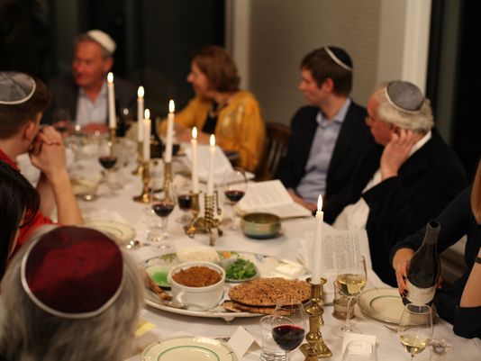

Passover, Pesach in Hebrew, is one of the most important Jewish holidays
The festival lasts for seven days between Nissan 15-22 in the Hebrew calendar
It has been celebrated every year in spring since around 1300 BC[E]
Passover is one of the most important Jewish holidays, celebrating the time when Moses led the Jewish people out of enslavement in Egypt to freedom.
The festival, Pesach in Hebrew, lasts seven days in Israel and for Reform Jews, however some congregations celebrate the holiday over eight days.
It has been celebrated every year in spring since around 1300 BC and involves rituals such as consumption of ceremonial foods and special prayers on Passover Seder nights.
Here’s all the information on Passover including what is it, when is Passover 2018 and why do Jews celebrate it.
When is Passover 2018?
Passover 2018 starts at sundown on March 30 and ends on April 7.
In the Hebrew calendar, the dates for Passover are Nissan 15-22.
The first night of Passover 2018 is March 30.
March 31/April 1 and April 6/7 are Yom Tovs. Yom Tovs translate as 'Good Days' and a time during which working is prohibited.
In 2017, Passover started on April 11 and ended on April 18.

What is Passover?
Passover is a Jewish holiday that celebrates the time when Moses led the Children of Israel from Egypt and enslavement. The story is set out in the Book of Exodus in the Old Testament.
The Book Exodus tells the story of how the Jews settled in Egypt when Jacob and his sons went there to be reunited with Joseph. As long as Joseph and his siblings were alive, the Jewish people were treated with respect in Egypt.
However, after Joseph died and a new Pharaoh came to the throne, the attitude changed. 'Behold the Children of Israel are more and mightier than we. Come, let us deal wisely with them; lest they multiply,' it says in Exodus 1:8-10.
The Jewish people became enslaved and the Pharaoh ordered for all newborn sons to be drowned in the Nile. One such newborn was Moses, who was saved from drowning when his mother placed him in a basket and set him down the river.
The baby is discovered by the Pharaoh’s daughter and names him Moses, which translates into English as ‘he who was drawn from the water’.
Moses grows up with the Pharaoh’s family but does not forget his true heritage. One day he sees an Egyptian slave driver beating a slave and kills him and flees Egypt to become a shepherd.
However, G-d intervenes and appears to Moses as a burning bush and tells him to go before the Pharaoh and demand that he ‘Let My people go, so that they may serve Me.’
The Pharaoh refuses and instead intensifies the Jewish people’s torment. Moses continues to return and demand freedom for the Children of Israel, each time the Pharaoh refuses, ignoring the warnings that G-d would smite Egypt with terrible plagues.

The Ten Plagues of Egypt
G-d turned the water of the River Nile into blood, causing all life in the river to die. Then all the water in Egypt turned to blood.
The second plague saw Egypt overrun with a swarm of frogs.
The Plague of Lice saw all dust turned into lice, which infected everyone.
In the fourth plague, all animals in Egypt died including horses, camels, sheep and goats.
A Plague of Flies fills every Egyptian house, including the Pharaoh’s palace.
The Egyptians are plagued by terrible boils.

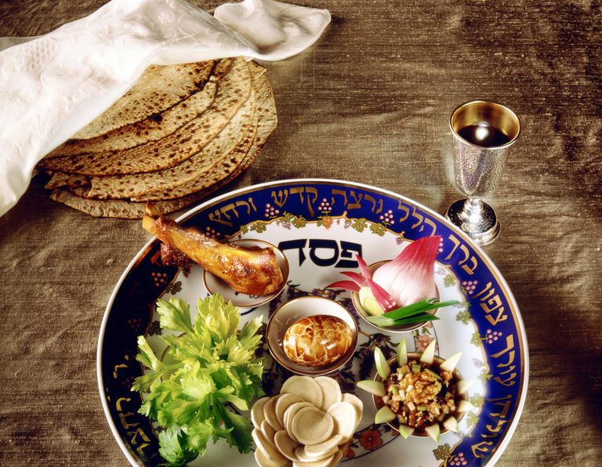

A Hail made up of fire and ice terrorises Egypt. The Pharaoh still refuses to free the Jewish people, ignoring the pleas of his people.
Anything that survived the hail, was then consumed by a Plague of Locusts.
Egypt descends into darkness for three days.
The tenth and final plague saw an avenging angel go to every Egyptian house and kill the first-born. On the stroke of midnight of Nissan 15, all of Egypt’s firstborn are killed.
To ensure the Children of Israel were passed over, i.e. weren’t touched by the angel, G-d ordered them to brush their door frames with the blood of a freshly slaughtered male lamb, then roast the lamb and consume it with bitter herbs and unleavened bread.
The Pharaoh gives in after the tenth plague and begs the Jewish people to leave. The Jews leave Egypt so quickly that they don’t have time to let the dough of the bread rise with yeast, meaning all their bread is unleavened.
However, the Pharaoh then changes his mind and pursues the Jews to force them to return. The Jewish people end up being trapped between the Pharaoh’s army and the Red Sea.
G-d orders Moses to raise his staff and suddenly the Red Sea parts down the middle, allowing the Jewish people to pass through.

Why do Jews celebrate Passover?
The Book of Exodus says how G-d ordered the Children of Israel to commemorate this period every year by removing all leaven and eating matzah instead.
'This day shall be for you a memorial day, and you shall keep it as a feast to the L-RD; throughout your generations, as a statute forever, you shall keep it as a feast,' it says in Exodus 12:14.
Passover meal, celebrations and traditions
The most famous part of Passover is the removal of Chametz (leaven) from the house. This means anything that is a ‘risen’ product of a combination of water and one of five types of grain (wheat, spelt, rye, barley and oat) are not allowed.
Fermented drinks such as beer and champagne are also not allowed.
On Passover Seder night, family and friends get together and follow a 15-step process that includes prayer, washing and eating foods in a specific order.
A passover Seder meal will usually consist of red wine, vegetables dipped in saltwater, matzah, bitter herbs such as horseradish and may feature matzo ball soup or gefilte fish.
Throughout the night, everyone takes part in reading passages from the Haggadah, which means ‘Narration’ and tells the story of how the Jewish people fled Egypt.
The part that kids probably look most forward to is the afikoman. On the Passover Seder table, under the Seder plate, there will be three matzahs.
The middle piece is taken and then split. The largest part of that piece is called the afikoman, from the Greek epikomen, which means 'that which comes after'. It is wrapped in cloth and eaten for dessert, a symbolic gesture to remember how quickly the Jews had to leave Egypt, when they wrapped their unleavened bread in their clothes.
The reason it may be the favourite part for children is because the afikoman is traditionally hidden in the house and the kids have to find it and bring it back to the table.

Reprinted from the February 20, 2018 website of the Daily Mail (United Kingdom)

Brooklyn torah gazette
For yom tov pesach 5778
Volume 2, Issue 30 (Whole Number 73) 15 Adar 5778/ March 30, 2018
Printed L’illuy nishmas Nechama bas R’ Noach, a”h

Pesah – Bedikat Hametz
By Rabbi Eli J. Mansour

The custom of the Arizal (Rav Yitzhak Luria of Safed, 1534-1572) was to hide ten pieces of bread that were smaller than a Ke’zayit throughout the home before Bedikat Hametz. This custom was undoubtedly based upon deep Kabbalistic reasons, but nowadays, it might be mandatory for Halachic reasons, as well.
We recite the Beracha of “Al Bi’ur Hametz” before beginning the search because we assume that we will find some Hametz, and thus the search is part of the process of eliminating Hametz from the home. Nowadays, however, the wives thoroughly clean the home well in advance of Bedikat Hametz, going through every area of the home and eliminating Hametz.
The real Bedika, therefore, was done before the formal search which we conduct on the night of Ereb Pesah. Therefore, if one does not spread some pieces of bread around the home before the Bedika, odds are that he will not find any Hametz, and his Beracha might then be considered a Beracha Le’batala (Beracha recited in vain).
Our situation is thus much different than the situation years ago, when the main search for Hametz was the formal Bedika, and it could be assumed that some Hametz would be discovered over the course of the search. For this reason, Rav Yosef Shalom Elyashiv (1910-2012) ruled that it is obligatory to put out ten pieces of bread before Bedikat Hametz.
This distinction between the situation today and the situation in years past can also help explain the common practice to conduct a brief, casual search on the night of Bedikat Hametz, rather than thoroughly searching through the entire house.
As noted by the Hida (Rav Haim Yosef David Azulai, 1724-1807) in Mahazik Beracha, those who do not conduct a thorough search rely on the fact that the home had already been cleaned well before the night of Bedikat Hametz, and care was taken to ensure that no Hametz was brought into the home. It is therefore acceptable to make a cursory search to fulfill the Misva.
Likewise, the car is usually cleaned before the night of Bedikat Hametz, and people just briefly check the car once more superficially, without thoroughly searching, to fulfill the Misva. Of course, it is proper to spend time searching, and there is educational value to searching for Hametz together with one’s children, but there is room to justify the common practice to search perfunctorily, since the real “Bedika” had already been done.
It is not advisable when distributing the ten pieces of bread to wrap them in aluminum foil, for the simple reason that aluminum foil is not flammable. If the bread is wrapped in foil, then it will have to be taken out of the foil the next morning for the burning, which could cause crumbs to fall. It is far preferable to wrap the pieces of bread in newspaper and close it with a piece of scotch tape, so then it can be easily thrown into the fire and burned the next morning.
If a house, for whatever reason, was not searched for Hametz, may one enter the home over Pesah? An example of such a case is one who owns a summer home that has food in it, and he does not plan on living in the home during Pesah, and so he simply sells the Hametz in the home, without searching for Hametz. If he needs to go into the home to get a suit or a book, for example, may he enter the home on Pesah, or is this forbidden, since there is Hametz in the home?
Rabbi Karp, in his work Hilchot Hag Be’Hag (p. 118), writes that one may enter a home temporarily during Pesah, such as to retrieve something, but one may not live there during Pesah. This applies also to the home of a non-Jew, who obviously has Hametz in the house. One may visit the home temporarily, but one should not live there during Pesah. One may perform a Bedika during Pesah if the home was not searched before Pesah, and may then live there, but if no Bedika is done, one may only enter temporarily. Rabbi Karp adds that if a synagogue was not checked for Hametz it is nevertheless permissible to learn and pray in that synagogue during Pesah.
Summary: There is a well-known custom to place ten pieces of bread throughout the house before Bedikat Hametz, and this custom should be followed, for both Halachic and Kabbalistic reasons. Nowadays, when the house is cleaned over the course of the days and weeks before Pesah, it is acceptable to make a brief search for Bedikat Hametz, though it is proper to spend some time searching with one’s family.
If one has a second home with Hametz in it and he sold the Hametz, without searching the home, he may enter the home temporarily during Pesah, but may not live there during Pesah, unless he first conducts a thorough Bedikat Hametz (which may be done on Pesah).

Reprinted from the March 21, 2013 email of Daily Halacha.com

Arab NGO Demands Ending Passover Ban on Chametz in Israeli Hospitals
By JNi.Media

The Haifa-based NGO Adalah (Justice in Arabic), an independent human rights and legal center, is fighting what it calls a ban imposed on Arab citizens because of the Jewish religious law forbidding consumption of leavened bread products during Passover holiday.
Adalah is demanding that Israel end the prohibition “on bringing leavened bread products into hospitals during the Passover holiday.”
“This ban imposes upon Arab citizens of Israel the Jewish religious law forbidding the consumption of leavened bread products during Passover,” the NGO protests the imposition.
According to Adalah attorney Sawsan Zaher, the group received the first complaint about the no bread policy imposed on an Israeli Arab three years ago, in HaEmek Medical Center in Afula, where, according to Zaher, a hospital official actually searched an Arab man who was visiting his wife. The Chametz products were taken away and he proceeded to have an unleavened visit with his wife.
According to a source we spoke to in another hospital up north which serves a mixed population, the Health Ministry issues ahead of every Passover holiday instructions regarding preparing the public kitchen for the holiday and preventing the presence of bread and bread products. However, our source was adamant that no one in her establishment would dream of challenging a visitor and searching their person for chametz.
The Jewish laws regarding “harboring” chametz in one’s environment are substantially different from the laws regarding kashrut in that non-kosher products must exceed a quantitative minimum or have a qualitative influence on kosher food to present a problem, whereas the presence of chametz on Passover is not similarly limited. In this way, a non-Jew who brings with him bread into a chametz-free environment theoretically turns it chametz for everyone else.
Adalah notes that 2017 marks the third consecutive Passover the group has initiated efforts to overturn the ban on Israeli Arabs bringing bread products into government run hospitals only to have Israeli officials fail “to provide a substantive response.”

-

Zaher noted that in 2016 the policy was being practiced at Rambam Medical Center in Haifa, and this year she knows of Carmel Medical Center in Haifa and HaEmek Medical Center in Afula where a similar policy is being enforced.
This report was written on Friday, and we were not able to get a response from the Israeli hospitals in question (the spokesperson’s offices were closed).
In a letter Zaher sent on Thursday to Attorney General Avichai Mandelblit and Health Minister Yaakov Litzman, the attorney noted that this is a “systemic policy implemented annually.”
Established in November 1996, Adalah “works to promote and defend the rights of Palestinian Arab citizens of Israel, as well as Palestinians living in the Occupied Palestinian Territory.” Its annual budget for 2014 was $1.4 million, received from private and government donors in Belgium, Germany, the Swiss Federal Department of Foreign Affairs, Netherlands, Sweden, Denmark, the UK, and the European Union.

Reprinted from the April 14, 2017 email of The Jewish Press.

A Message from the Kalever Rebbe for Pesach 5775

Reclaiming Our Children

Erev Pesach 5775 marks approximately 70 years since the horrors of the Holocaust in Europe drew toward an end. Amongst the 6 million holy Jews who were cruelly murdered. We Jews recognize that the future of our sacred religious path and mission to the world lies with our children.
The recent tragedy of the seven beautiful Sassoon children who perished in a home fire on Shabbos is a fresh and excruciating blow to our national psyche. We all grieve together with the parents and pray for the recovery pf Mrs. Sassoon and her daughter. At the same time we were all inspired and awed by the depth of spiritual strength exhibited by Gavriel Sassoon. His profound faith ennobled us all and his simple message is one we all must heed. Love your children.
This serves to bring into sharp relief a most vexing and distressing issue which confronts us at this time, perhaps in greater measure than at any other time in our history; the loss of so many Jewish children to assimilation and intermarriage at a most alarming rate. Pesach is the particular holiday that is singularly focused on the paramount importance of faithfully transmitting to our children the story of our redemption from enslavement to Egypt and its depraved culture, and our consecration into the holy service of G-d A-mighty. What are the lessons this Yom Tov imparts to us and how can we incorporate them into our daily interactions with our own precious children?
One of the highlights of the Haggadah is the passage regarding the Four Sons - one wise, one wicked, one simple, and one who is unable to ask. Who are these children? What accounts for their divergent paths in life?
In fact, we find echoes of these timeless archetypes manifested in our own recent history. From the late 19th century through the 20th century, particularly post Holocaust, many Jews immigrated to the United States to escape the persecutions of Russia and Nazi Europe. Upon reaching the shores of the “Goldene Medinah,” many of these Jews cast off what they considered to be the shackles of strict religious observance. Nevertheless, first generation immigrants who remembered the Jewish practices of their parents and grandparents maintained a tenuous connection to their Yiddishkeit.
However, the most detrimental step they took in weakening Jewish continuity was depriving their children of a solid Torah based education, as many sent their children to public schools. Their association with gentiles and non-observant Jews, coupled with watered down practice at home, led to resentment toward religion and increasing ignorance of Torah and Mitzvos. Invariably, the fourth generation lost any connection at all to the religion and traditions of their holy ancestors. This culminated in their total assimilation into secular society and a very high rate of intermarriage.
Perhaps this generational devolution is described in the Haggadah’s account of the four sons:
1) The Wise Son represents the first generation, still knowledgeable of the Jewish practice of his parents and grandparents. He maintains interest and is hungry to learn more.
2) The Wicked Son represents the second generation that becomes estranged from, and resentful of, religious restriction after experiencing the liberal lifestyle of the secular world surrounding him.
3) The Simple Son represents the third generation, all but ignorant of Judaism but still interested enough to ask, “What’s this?”
4) The Son who knows not how to ask is unfortunately so assimilated and far removed from religious identity that he doesn’t even know to ask about what he is missing, may Hashem protect us!
In our time, much to our dismay, we find that the influence of religious abandonment has infiltrated even into the most observant homes. This can be largely attributed to the unchecked and unsupervised proliferation of communication technologies which expose our children to all manner of immoral and deviant thinking. It also facilitates instant and ubiquitous conversations and encounters with people from all walks of life including those who mean to do harm to our precious children.
How do we combat these myriad negative influences and turn the tide in favor of, what we know to be, the sweet blessed path of Torah and Mitzvos?
The Hagaddah provides for us the first key. Make sure that you maintain a strong connection with all of your children. Always endeavor to cultivate a positive personal relationship with your children by demonstrating your love for them. Shower them with words of praise whenever appropriate. In turn, love will grow in their hearts for you and the lessons you are teaching them, as Scripture teaches “and I will return the hearts of the fathers to the children and the hearts of the children to the fathers” (Malachi 3:24).
At the same time, we also need to rebuke our children when necessary. But we must do so in a pleasant manner which offers more words of praise than harsh criticism. Rabbi Shlomo, the Rebbe of Radomsk wrote in his Sefer “Tiferes Shlomo” in the name of the tzaddikim of his generation, (commenting on Pirkei Avos 1:6), that one should rebuke others with pleasant words which will draw their hearts closer and inspire them to Yiras Shamayim. If he wrote these words for his generation, all the more so how much we must conduct ourselves in this manner in our times.
It is also critical that as parents, we do not abdicate educational responsibility solely to the schools. Even as we are involved in our own career pursuits, we must make time for our children. When my own grandfather, the Holy Tzaddik Grand Rabbi Yissochar Dov, the Linsker Rebbe, zt”l, was a young child, he studied together with a grandson of the holy Rebbe Yehoshua of Belz, zt”l. Every week the Belzer Rebbe tested both of them on their studies and afterward served them sweet fruits to eat. Take note, my grandfather was born in the year 5642 (1882), which was near the end of the life of the Belzer Rebbe. The Belzer Rebbe was a very busy man, one of the elder Rabbis and greatest Jewish leaders of his day. Yet, he always set aside time from his very busy schedule to see to the education of his grandchildren and their friends. We must assimilate this important practice into our schedules as well.
The night of the Passover Seder, when there is a special mitzvah to recline with one’s children and tell them the story of the Exodus from Egypt, is the ideal time to personally rededicate ourselves to repairing our relationships with our children and taking an active role in their education and development, recognizing that the continuity of the Jewish People depends on this.
Indeed, the Torah stressed the necessity of parental commitment in the way it commanded the very first offering of the Korban Pesach in Egypt. It began with preparation, several days ahead of time, tying the lamb to the bedposts. Afterward, the meat of the Korban Pesach had to be eaten quickly. This demonstrated to the children our love and enthusiasm for the mitzvah and the level of care taken in its preparation. Indeed, education encompasses everything a child sees and hears, even indirectly.
Furthermore, Halachah dictates that to partake of the Korban Pesach, one must be “counted in” ahead of time, in accordance with the verse, “a lamb for each family, a lamb for each household.” This teaches the importance of fellowship in the family unit. Additionally, one must be pure in order to partake of the korban. It is prohibited to share the Korban with heretics and people of low character who might exert negative influences over us and our children. Finally, we do many things to encourage the children to ask questions. This strengthens the bond between parents and children and will encourage strong identification, rather than assimilation.
Let us seize the special opportunity that Pesach affords us to renew the bonds of love and religious affiliation with our beautiful children. They are truly G-d’s most special gifts to us. And we owe Hashem our sacred commitment to ensure that they follow in His holy path of Torah and Mitzvos, on Pesach and always.
May this Pesach usher in a season of joy and redemption for all of Klal Yisrael and bring abundant blessing to you and your families. Finally, we pray for the fulfillment of the verse, “as in the days we left the Land of Egypt may we see wonders”, Amen!

Emailed by the Kalever Rebbe for Pesach 5775 (2015).
N.Y. / REGION

The Grape Juice
Wars of Passover
By Joseph Berger

Employees stacking Kedem’s grape juice at Wasserman’s Supermarket in Queens. The entry of Welch’s Manischewitz into the kosher juice market has set off a turf battle with Kedem.CreditHilary Swift for The New York Times

For most Americans, grape juice is an occasional treat. For Orthodox Jews, it is an obligation.
Orthodox Jews bless and drink a cup of wine three times on the Sabbath and four times at each of the two Seders for Passover, which will begin at sundown on Monday. Parents often buy grape juice so the children can accustom themselves to fulfilling the commandments. And since Hasidic and other ultra-Orthodox families typically have six, seven or more children, that’s a lot of grape juice.
Welch’s, the American titan of grape juice, has noticed. It has flooded the Orthodox market, having made its intentions clear last year when it teamed up with the kosher colossus Manischewitz. This year, Welch’s Manischewitz demonstrated that it really meant business by turning out juice with an additional kosher certification from a panel of exacting rabbis from the rigorous Hasidic and ultra-Orthodox communities.
“You’re getting two powerhouses coming to this market,” said Sara Stromer, the assistant brands manager for Manischewitz, which is supplying Welch’s with its expertise in distribution to the kosher market.
But in doing so, the almost 150-year-old Welch’s, whose name is practically a synonym for grape juice, and the 129-year-old Manischewitz, the world’s largest matzo manufacturer and a kosher wine and food producer, have set off a fight with the long-reigning emperor of kosher grape juice, Kedem.
The move demonstrates the lengths some Orthodox Jews will go to make sure they are keeping kosher by standards that might seem esoteric to the outside world. The more stringent designation seems to be aimed squarely at a growing sector of the Jewish population. A UJA-Federation of New York study released in 2012 showed that 40 percent of the city’s 1.1 million Jews were Orthodox, as were 74 percent of the city’s Jewish children. In a similar study 10 years before, the percentage of Orthodox among the city’s Jews was 33 percent.
The turf war has been especially evident in the frenzied weeks before Passover — a season when 40 percent of all kosher products in the United States are sold, according to Menachem Lubinsky, the publisher of the online newsletter Kosher Today — in heavily Orthodox neighborhoods like Kew Gardens Hills in Queens or Williamsburg and Borough Park in Brooklyn, and in Orthodox towns like Lakewood and Teaneck in New Jersey. The Welch’s Manischewitz opening shot has been a series of steep discounts.
In Kew Gardens Hills, an enclave of garden apartments and modest houses, where Paul Simon and Art Garfunkel grew up in the 1950s, customers at Seasons supermarket on Main Street could for two days in late February buy a 64-ounce bottle of Welch’s Manischewitz Concord grape juice for $1.99. With a coupon for an extra $1.50 mail-in rebate, they could end up buying the bottle for 49 cents.
The price in late March was $3.49, but that was cheaper than Kedem’s 64-ounce bottle, which sold for $4.99, and Welch’s Manischewitz still offered the same rebate. Eli Siegel, the manager at Seasons, said he sold about 400 bottles a week of Welch’s Manischewitz.
Shulem Brach, the manager of Wasserman’s, another supermarket a half-mile down Main Street, said that in his store Kedem responded not by lowering prices but by offering jumbo 96-ounce bottles (usually sold only in warehouse clubs like Costco) for $6.49. “That way people can get more value for their money,” he said.
Officials of Kayco, which distributes Kedem, declined to comment beyond an email from its chief executive, Mordy Herzog, that said: “We welcome the competition. Our primary emphasis has been to deliver a quality product at fair prices for six decades, and we are confident of the continued loyalty of our customers.”
` Mr. Brach, a Satmar Hasid, said Kedem juice sold far better than Welch’s Manischewitz. “People are still afraid to take Welch’s because it’s new,” he said.

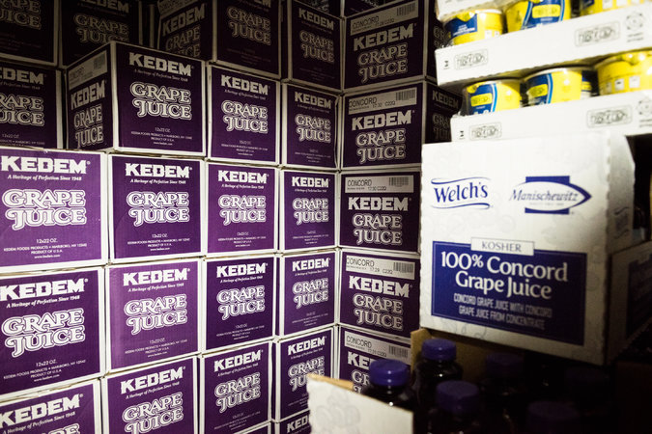

The kosher juice rivalry is especially evident in the frenzied weeks before Passover, when 40 percent of all kosher products in the United States are sold. CreditHilary Swift for The New York Times

Welch’s Manischewitz has not yet instilled the comfort zone Orthodox Jews require to consume new kosher products. The biblical laws of kashrut (the rules for permissible foods) specified the types of animals that could and could not be eaten, forbade the mixing of milk and meat and, on Passover, prohibited the eating of leavened bread (as a way of commemorating the Israelites’ hasty flight from Egypt, which did not allow time for dough to rise).
In the following millenniums, the sages expanded these prohibitions with a welter of interpretations intended to fortify the taboos against forbidden foods. A commandment in Exodus and Deuteronomy not to cook a young goat in its mother’s milk became, in modern times, an insistence on separate dishes, cutlery, sinks and dishwashers for meat and milk products.

Yehuda Berger, 15 months, waiting for his mother in juice aisle of Wasserman’s Supermarket.CreditHilary Swift for The New York Times

Grapes are inherently kosher, but the rabbis of the first centuries of the first millennium wanted their religion to avoid any resemblance to cults whose followers would pour wine on the ground as an offering to idols. They specified that wine — or nonalcoholic juice of the grape — be watched over by observant Jews from the time of the grapes’ crushing to the juice’s bottling. They also recommended cooking the wine, because removing flavor would assure that it would never be used for idol worship.
Observant Jews are assured a food is kosher by a seal — known in Hebrew as a hechsher — on the label. The most common imprint is the letter U circled by the letter O, the symbol of Orthodox Union, the world’s largest kashrut certifier, which is based in New York. Its imprint appears on 800,000 products in 100 countries, including cans of Coca-Cola and Hershey bars. But Hasidic sects and ultra-Orthodox Jews prefer to see certifications from their own tribes. “It gives them a sense of comfort and independence,” said Rabbi Menachem Genack, chief executive officer of OU Kosher.
Rabbi Shmuel Teitelbaum, whose rabbinical court, Minchas Chinuch Tartikov, certified Welch’s, said that in September some 20 rabbis ventured to a factory in Westfield, N.Y., outside Buffalo, and monitored the grapes for a week.
“The OU is an extremely high standard,” Rabbi Teitelbaum said. “But we represent the ultra. We call ourselves super-kosher.”
Welch’s first made an effort to enter the kosher market in the 1990s but pulled out after a year. This time it hopes the pairing with Manischewitz and the extra certification will make the difference.
Mr. Lubinsky, who also produces the annual Kosherfest trade show in Secaucus, N.J., predicted that Welch’s Manischewitz would have “an awful hard hill to climb” because of Kedem’s history with Orthodox families. “It’s difficult to make people change even if you make the argument your taste is better,” he said. “It has everything to do with ingrained taste buds going back generations.”
He did note that matzos manufactured in Israel have slowly been able to cut into the markets of brands like Manischewitz and Streit’s with lower prices, despite complaints that the Israeli companies have the advantage of government subsidies and cheaper labor.
Kedem is not an obscure brand. It is the flagship of an enterprise whose roots stretch back to Mr. Herzog’s ancestors in what are now the Czech Republic and Slovakia in 1848.
But Welch’s is almost as venerable. It was started in 1869 by Thomas Bramwell Welch, a Wesleyan Methodist who advocated temperance and urged grape juice as a substitute for wine in the Eucharist.
A customer at Seasons, Marilyn Iseson, said she liked the Welch’s Manischewitz bottle’s rectangular shape, which takes up less space than the round Kedem bottle. “I always bought Kedem, but now I buy whatever’s on sale,” she said.
Shopping at Wasserman’s, Chava Hakimian, a mother of five, said she would buy either brand because her children didn’t discriminate.
“They like grape juice,” she said. “I don’t think they notice the difference.”

Reprinted from the April 7, 2017 website of The New York Times. A version of this article appears in print on April 9, 2017, on Page MB4 of the New York edition with the headline: The Grape Juice Wars of Passover.

How to Prepare Your Seder Plate Items Quickly & Easily
By Miriam Szokovski

Preparing the Seder plate items can seem overwhelming, but it needn’t be.

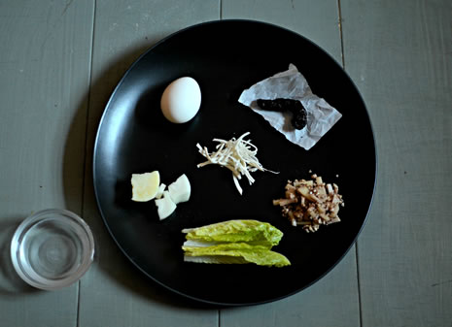

Although there are six or seven different components, none of them are particularly complex. Here I’ll explain what each element represents, how it’s prepared and when it’s used. For more detailed information, check out the Seder preparation section on our Passover site.
Please note: Some of the items used may vary depending on your community and family. I am going according to the Chabad custom.
Zeroa: The Shank Bone
The shank bone represents the paschal sacrifice brought in Temple times. For this we use a chicken neck, roasted on the stovetop.
Hold the chicken neck over a burner with a pair of tongs, until blackened on both sides. Prepare one for each Seder plate. The shank bone is not eaten, and the same one can be used for both nights.

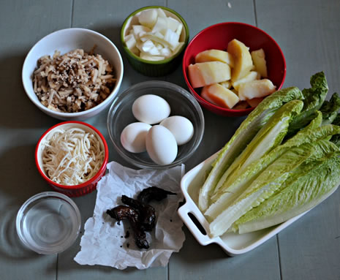

Beitza: The Egg
The hard-boiled egg represents the holiday offering brought in Temple times.

Prepare one egg per Seder plate. You may also wish to prepare one for anyone else at the table who is not using a Seder plate.
The egg is traditionally dipped in salt water and eaten at the beginning of the meal.
To prepare: Place the eggs in a pot and cover with cold water. Cover the pot and bring to a boil. When the water reaches a rolling boil, turn the fire off and leave the eggs in the covered pot for about 12 minutes. For easier peeling, run the eggs under cold water.

Maror: The Bitter Herbs
The bitter herbs remind us of the bitter slavery and exile in Egypt.

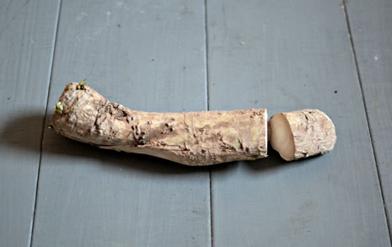

We use freshly grated horseradish root wrapped in romaine lettuce.
To prepare the horseradish, peel and grate the horseradish root. You can use a hand grater or a food processor. Store in a glass jar for maximum freshness.

Chazeret: The Lettuce
The lettuce symbolizes the bitter enslavement of our fathers in Egypt. The leaves of romaine lettuce are not bitter, but the stem, when left to grow in the ground, turns hard and bitter.
Likewise, when we were enslaved in Egypt, at first the deceitful approach of Pharaoh was soft and sensible, and the work was done voluntarily and even for pay. Gradually, it evolved into forced and cruel labor.
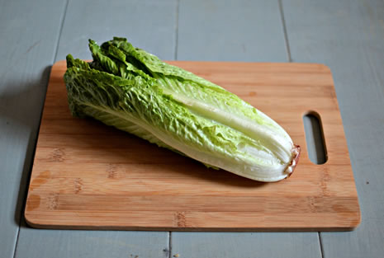

To prepare the lettuce, wash it well and check for bugs. I find the easiest way is to cut off the stem and place the leaves in a big bowl of water. Remove and check each leaf, and pat dry with a paper towel.

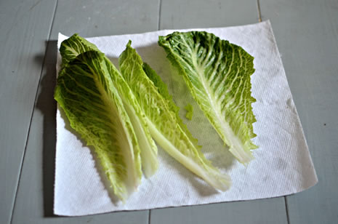

The lettuce and bitter herbs are used twice. After we finish the maggid portion of the Seder, when we tell most of the story of the Exodus, we wash hands and eat the matzah. Then we eat the maror (the grated horseradish wrapped in a couple of lettuce leaves), and after that, we eat the sandwich (another dose of horseradish and romaine, this time sandwiched between matzah).

Charoset: The Paste
Charoset reminds us of the bricks and mortar the Jewish people were forced to make while enslaved in Egypt. We use it as a type of relish, into which the maror is dipped (and then shaken off).

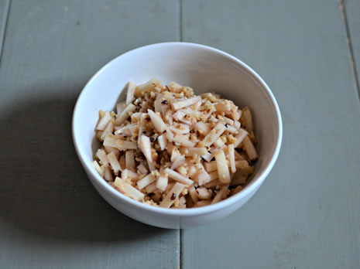

For a basic charoset, mix together 1 finely diced apple, 1 finely diced pear, 1 cup ground walnuts and ½ cup red wine.
Check out more variations here.
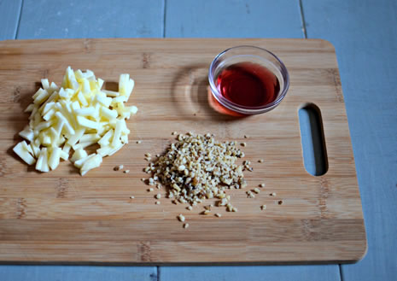
Karpas: The Vegetable
The vegetable alludes to the backbreaking work the Jews did in Egypt. The letters of the Hebrew word karpas can be rearranged to spell perech samech. Perech means backbreaking labor, and samech numerically alludes to the number of Jews enslaved in Egypt.
The vegetable is dipped in salt water and eaten at the beginning of the Seder, after saying kiddush and washing hands. The Chabad custom is to use a piece of cooked potato or a piece of raw onion, but many others use parsley, radish or celery.

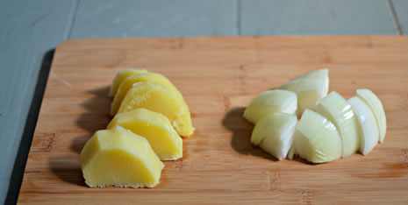

Peel and cut a potato and place in a small pot with enough water to cover. Bring to a boil and cook until the potato is fork tender. For the onion, just peel and cut into chunks. Prepare enough karpas for each person at the Seder.

The Salt Water
The salt water represents the bitter tears our ancestors shed while enslaved for so many years. It is placed in a small bowl next to the Seder plate, and both the karpas (vegetable) and the egg are dipped into it.

Make the salt water by mixing 1–2 tablespoons of salt into 2 cups water.
And that’s it . . . you’re done!

Here are some tips to help your Seder plate preparation go quickly and easily.
Make a list so you can cross off each item as it’s done.
If your kitchen is Passover-ready in advance, get a couple of items ready early. The shank bone can be frozen after it’s roasted, for example. And if you put the lettuce in a Ziploc bag with all of the air squeezed out, it stays fresh and crunchy for a good week. Eggs can be boiled 1–2 days before, and the salt water can be prepared at any time. It also literally takes about one minute.
Multitask. Keep in mind that the cooking of the eggs and potato is “passive time.” You can use this time to prepare other elements.
Grate the horseradish in a separate room, or even outside. When it is very fresh and potent, it can make everyone’s eyes sting, just like onions. When grated, that carries through the air and is particularly strong.
The most time-consuming task is probably the washing, checking and drying of the lettuce. If you have kids around, this is a good job for them.
The amount of time it takes will largely depend on how many people you are preparing for. If you have a big crowd, delegate! Ask people to chip in and hand out specific jobs.
Happy Passover!
Repinted from the Pesach 5777 website of Chabad.Org
The Abarbanel on Parshat Bo

The Reason(s) for
Eating Matza
By Rabbi Pinchas Kasnett

Every year at the Pesach seder we repeat the words of Rabbi Gamliel from the Haggadah: “What is the reason that we are eating this matza? it is because when G-d redeemed them from Egypt there was not enough time for their dough to rise and become leavened, as it says in the Torah, ‘They baked the dough that they took out of Egypt into unleavened cakes, for they could not become leavened since they were driven from Egypt and they could not delay….’ ”
The first difficulty here according to Abrabanel is that even prior to their hasty exodus G-d had already commanded them to eat matzot and avoid all leavened products. The matzot were to be eaten with bitter herbs along with the sacrificial Pesach lamb on the night before they were to leave Egypt.
Why then does Rabbi Gamliel refer only to the unleavened dough that they took with them when they left in haste, and not to the matza which they had eaten the night before?
Additionally, the verse from the Torah is very enigmatic. What does the Torah mean by “for they could not become leavened”? It would appear that just the opposite would have occurred. The verse refers to their having reached succot, their first destination after having left Egypt several days before. surely the dough would have risen and become leavened during that time. How then could they bake it into “unleavened cakes”?
Abarbanel answers as follows: Rabbi Gamliel is giving the main reason why we eat matza every year at the seder. However, G-d gave the command to eat matza and refrain from leavened dough before they left Egypt in order to magnify the extent of the sudden and miraculous mass exodus of the entire Jewish population.
The people were eager to fulfill the mitzvah of matza, and they kneaded the dough under the assumption that they would be able to bake it before leaving Egypt. However, before they could accomplish the baking Pharaoh issued the expulsion order, and they hastily packed the unbaked dough, carrying it on their shoulders.
Days later, when they reached succot, they were able to bake the dough, and although they were afraid that the dough would have become leavened by that time, G-d miraculously intervened and they were still able to bake unleavened matzot from that dough.
The entire incident was designed to impress upon them and further generations that the haste with which they left Egypt, together with the subsequent miraculous baking of the matzot, was an additional demonstration of G-d’s direct hand in all aspects of the exodus from Egypt.
Additionally, G-d commands us to refrain from eating leavened dough for a full seven days in order to further connect us to the miraculous redemption. To refrain from eating leavened products for a day or two would not be a sufficient reminder for later generations of the hasty exodus, as it is not at all unusual for people to refrain from such products randomly for short periods of time throughout the year.

Reprinted from the Parshat Bo 5777 email of OHRNET, the Ohr Somayach Torah Magazine of the Internet.

A Slice of Life

The Wise Son
By Rabbi Dror Moshe Shaul

It was just a few minutes before Passover when a couple with two daughters walked into our Chabad House in Dharamasala, India. The mother introduced her husband and children. She said they had just arrived from an organic food farm near Chennai in southern India, a distance of a week's travel by car from Dharamasala, and it was very important to them to celebrate Passover with other Jews. Since they had heard there was a Chabad House in the area, they had chosen to make the trip.
The couple apologized for arriving at the last minute and asked whether they could still register. They added that they were vegans and also do not drink wine. "We will manage with matza," said the father.
Of course I told them they were welcome to join us, and food was no problem since we had plenty and there were even vegetarian courses. And that is how we came to host this wonderful family. They ended up staying with us for the entire Yom Tov; first, because they really enjoyed our company and second, because their children became friends with my children.
Friday night the atmosphere was particularly friendly and the father decided to share a personal story he had with the Rebbe. This is what he said:
"It was 1985. I was a soldier in the IDF and serving, like many of my comrades, in Lebanon. It was very rough going and the IDF sustained losses every day.
"One day, a bomb landed on our position, and as a result of the powerful blast, one of my kidneys was severely injured. I was taken by military helicopter to Rambam hospital in Haifa where I lay unconscious. I was in critical condition and hovered between life and death. The doctors felt helpless and were afraid I had contracted a kidney infection, so they decided to gamble on a dangerous treatment in which the affected area is attacked with strong medication that destroys all the diseased cells. The great danger in this treatment is that it also destroys the good antibodies and many people die of this protocol. And yet, they had no other way to treat me.
"Since I was unconscious, they asked my parents for permission to carry out this treatment. They informed my parents that this could not be postponed and every minute was critical. If they did not give me the proper treatment, and if this was in fact an infection of the kidney, my condition would be irremediable. They wanted to begin treatment as soon as possible.
"My parents did not know what to do. Since this was a life and death matter, they continued to vacillate. It was a Thursday night. They were asked to make a final decision that same night and on Friday, the doctors prepared to begin treatment.
"A good friend of my father, Rabbi Yosef Helfinger of Jerusalem, was staying with my parents at the time. He is a Lubavitcher Chassid, and when he saw my father's dilemma, he suggested that he consult with the Rebbe. My father, who was not religious, did not understand why the Rebbe would know more than the doctors. He wasn't enthusiastic about the idea, but since this was a critical decision and he had nothing to lose, he agreed to ask the Rebbe. That same evening, a fax marked 'urgent' was sent to the Rebbe with the details of the medical situation.
"The Rebbe's answer arrived a few hours later. It said not to give the treatment and I would recover. My father told the doctors the Rebbe's answer. They did not understand how he could rely on some rabbi living in New York.
"The unbelievable happened. After Shabbat a new CT scan showed that I was not suffering from what they had feared. My parents turned white when they found out that if they had given me the treatment on Friday, I would no longer be alive.
"In light of the new findings, I underwent a complicated operation, after which my condition continuously improved. A while later, my parents were informed that I was out of danger. It took a little while longer until I regained full consciousness. Within a few weeks I was healed of my wound and released from the hospital. You see me here, still not religious, but I had an open miracle with the Rebbe and thanks to the Rebbe I am here with you. I am full of appreciation and thanks to the Rebbe who saved my life."
The man, a clinical psychologist, has been living with his family in India for nine years now. He and his wife run an organic farming plantation, which has thousands of volunteers passing through every year. Every Friday they hold a meal for several hundred people in which they explain the principles of ecological naturalism. They have influenced thousands of people around the world.
As we spoke, I learned that their family name is Ruzhin and that they are descendants of the Ruzhiner Rebbe. I told the family about the close relationship between Chabad and Ruzhin and they were interested in hearing some stories about the Ruzhiner Rebbe.
When Passover ended, the Ruzhin family left on their exhausting trip back home. Before they left, we gave them mezuzot as well as a picture of the Rebbe. The father, who was very moved, said he would hang the picture in the foyer of his home and would tell everyone who came that he owes his life to this man.

Reprinted from last year’s Parsha Metzorah 5776 edition of “L’Chaim Weekly,” a publication of the Lubavitch Youth Organization in Brooklyn, NY. Reprinted from Beis Moshiach Magazine
Seder in Children's Home. Rosenheim, Germany After War

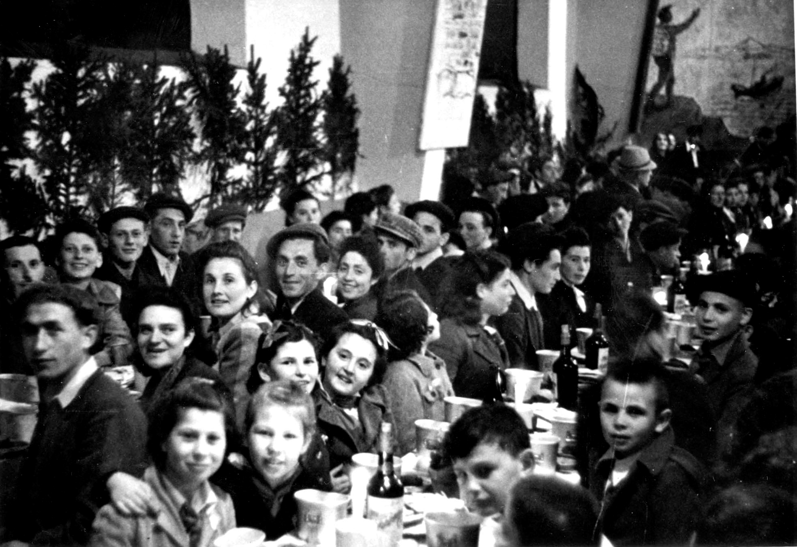

Reprinted from the website of Hidabroot.com

Pesach Sheni and
Rav Yaakov Tzvi Emden

HaRav Yaakov Tzvi Emden, Zt”l (the Yaavetz) writes in his Siddur that:
“It was revealed to me from Heaven why Pesach Sheni was established on the 14th day of Iyar. After all, it would not require more than two weeks for anyone who was impure or too far away on Pesach itself to come to Yerushalayim and bring the Pesach Sheni. So, why wait a month from the 14th of Nissan to the 14th of Iyar--the Pesach Sheni could have already been brought by Rosh Chodesh Iyar?”
The reason given to HaRav Emden from Heaven was that Bnei Yisrael had sufficient Matzos to last from the time of our Exodus from Mitzrayim for 30 days--until the night of the 15th of Iyar! In other words, the Exodus, and all of the Kedusha that came along with it, actually lasted for a full month after the night of Makkas Bechoros and our gathering to leave the next morning. The holiness that extended from Yetziyas Mitzrayim, then, extended until Pesach Sheni!
The Torah teaches (Bamidbar 9:10) that the actual Korban Pesach Sheni is brought when a person cannot bring the Korban Pesach in its proper time--either because, for example, he was rendered impure, or because he was too far away from the Courtyard of the Bais HaMikdash at the time the original Pesach offering was to be brought. The Luach Dovor B’Ito writes that a great lesson of Pesach Sheni is that it teaches us that it is never too late, and it is always possible, to Remove your tumah--shed your impurity, and to come closer to Hashem after Having been too far away. Accordingly, Pesach Sheni is a time of reflection and Teshuva. We should take some time out to properly utilize the opportunity of the day.
One final point on Pesach Sheni: there is a difference in custom as to if and when one eats Matzah. According to one opinion, one should not eat Matzah, for it may appear as if he is attempting to fulfill the Mitzvah of Matzah in an improper time, which is a violation of the Torah’s prohibition against adding onto the 613 Mitzvos. Others have the custom to eat Matzah sometime during the day on the 14th, to remember that the Korbon Pesach Sheni was brought today.A third opinion is to eat the Matzah tonight, i.e., the night of the 15th of Iyar, for this would be the night that the Korban Pesach Sheni was eaten together with Matzah and Marror. Every person should follow his custom, or his Rav’s guidance, in this area.

Reprinterd from the May 20, 2013 email of the Hakhel Community Awareness Bulletin.
Haggadah: An Introduction
By Rabbi Shimon Apisdorf

Putting the Seder into perspective.
Why do we Read the Haggadah?

The holiday of Passover marks the anniversary of the birth of the Jewish nation. The story of the Jewish nation is one of individuals who became a family who became a people. The great individuals who laid the spiritual foundation of Jewish peoplehood were Abraham and Sarah, their son and daughter-in-law Isaac and Rebecca, and their son and daughters-in-law Jacob, Rachel, and Leah.
From Jacob, Rachel, and Leah came a family of 70 people who, due to a famine in Israel, were forced to migrate to Egypt. In Egypt this family grew and prospered to such an extent that they eventually came to be seen as a threat by their Egyptian hosts. Respect and admiration turned to contempt, and finally to an organized program of enslavement and oppression. After 210 years, and a series of unheeded warnings by Moses to Pharaoh which resulted in the Ten Plagues, God liberated a nation which had grown from the original family of 70 people. Seven weeks later this newly conceived nation received the Torah at Mount Sinai.
The Haggadah is the story of the birth of the Jews as a people. It deals primarily with the events in Egypt which led from slavery to liberation, though it also spans the entire period from Abraham to the giving of the Torah at Mount Sinai. One could say that the Haggadah is our national birth certificate as well as our Declaration of Independence. More than just a historical document, it also speaks of the ideals and values which constitute the essence of our national consciousness and identity.
The word haggadah means to tell, or to relate. The Haggadah is a vivid narrative which is set in the context of a parent-child dialogue. Passover, with the Haggadah as its focus, tells every Jew three things: who you are, where you came from, and what you stand for.
The message inherent in the Haggadah is that Jewish identity and continuity hinge on encouraging children to ask questions -- and being prepared as parents to provide sensitive and substantive answers. In Judaism, being learned, knowledgeable, and wise is not only a goal, it's a prerequisite.

Putting the Seder
Into Perspective
Rabbi Shraga Simmons

The story is told of Dan and Bob, two homeless people who are talking one afternoon.
Dan says: "Do you know what tonight is? It's the holiday of Passover. That's when the Jews have the Seder feast -- the fine food and delicious wine -- all served in the most elegant manner. I went to a Seder last year and it was incredible. All you have to do is go to the synagogue tonight, and when the services are over, someone will invite you to their home."
That evening, the two friends stand in the back of the synagogue waiting. Sure enough, when services are over, they each get invited to separate homes for the Seder. "Good luck," says Dan, "you're gonna love it."
At the Seder, Bob is really excited. He's hungry and hasn't had a home-cooked meal in months. He can already smell the delicious food wafting from the kitchen. He sits patiently as the family reads in a language he doesn't understand. He's getting hungrier, but finally he sees a plate of food being passed around. But it's only little pieces of celery (for the "Karpas")! After this, they go back to reading from the book.
An hour goes by and Bob is really hungry now. He's willing to eat anything. Finally they pass around some Matzah and Bob takes a big piece. Then they serve a bowl of some white vegetable and Bob heaps a big pile on his plate. He stuffs his mouth full with it and ... FIRE!!! The horseradish burns Bob's mouth and stomach, and he runs out of the house screaming and cursing.
Later that night, Bob and Dan meet up again. "I'm so mad at you," shouts Bob. "You sent me to a Seder and it was terrible."
"What do you mean?" says Dan. "At my house, they had incredible fish, soup, chicken, kugel and dessert! All you had to do was hang in there and you'd have gotten yours, too!"

This story captures the theme of Passover night. On one level, it is a metaphor for the dramatic turnaround of events the Jews experienced in Egypt. They went from the bitterness of slavery to the glory of freedom -- all in one day. So too, when we feel enslaved and in pain, remember that God can redeem us in the blink of an eye.
On another level, this story is a good introduction to the Seder itself. The Seder goes from bitter herbs to feast in a matter of moments. For while the Haggadah may seem long at times, hang in there. Food is on the way!
(story attributed to Rabbi Nachman of Breslov)

Lessons for Life
Rabbi Stephen Baars

Each Jewish holiday is a lesson in life. What is the unique lesson of Passover? Freedom. It's the type of freedom that has given the Jewish people it's power to survive and to thrive. It's not a freedom of the body as much as a freedom of the spirit. And this freedom is available at Passover-time to help you achieve whatever you want. A person with true freedom knows no bounds, and can achieve whatever they wish. They are free to change themselves and change the world!
On Sukkot, the holiday of joy, we focus on the need to increase our joy. On Rosh Hashana, we commit to working on goals. On Yom Kippur, we focus on a sense of regret and a returning to where we should be. On Passover, the holiday of freedom, everyone thinks they are free.
The challenge of Passover is to appreciate that this may not be true.
Slavery takes many forms; not all shackles are made of iron. Once slavery becomes a way of life, the slave may even become unaware of his own servitude. Passover is a "virtual reality experience" in freedom -- and the Haggadah is our guidebook. It assists each Jew in unearthing his own "slavery." The Seder is a seminar on how to be truly free, and on Passover night we can reenact the transformation of leaving Egypt, from slavery to freedom.
Out of the original events of Passover emerged the greatest and longest standing empire of the world. Not an empire of space but an empire of thought -- Jewish thought. The story of Passover is the story of the beginnings of the Jewish people, a people that set out to form a "new world order" with a new morality and new concepts of life.
The 'old' world was a pagan one, where war and violence were not only ways of life but often national pastimes. The world the Jews ushered in includes ideas with which we are all familiar -- equal rights, universal education, social responsibility, and peace for mankind.
Experiences come through two vehicles: Experiences of the body, and experiences of the mind. Passover is a "mind" holiday. We have to become free -- not from a physical oppressor, but from a spiritual, mental one. Ideas may enslave us. Pressures, self-imposed limits -- all these are in our mind. To be free of them, we must first understand them. But first we must become aware of those things that enslave us on a 'subconscious' level.
That's why the Haggadah encourages us to ask questions to exercise our mind. So as you encounter questions throughout the Haggadah, take them seriously. Try to answer them, and encourage others to ask more questions.
Give each of the guests some candies before the Seder starts, so that they can toss a candy to whoever asks a good question. This is a particularly effective way of keeping children interested.
The key is that the Seder should be relevant, not dry and boring. Read ahead, familiarize yourself with the text and look for interesting questions to discuss during the Seder. Circle those points you want to read out during the Seder and write in your own comments.
Discuss the ideas in a deep and meaningful way. Don't just rush through the text in order to get to the meal! One good way to start your Seder is by asking everyone to recollect their childhood experiences of what their Seder was like.
If everyone at the Seder is thinking, then the Haggadah seminar is sure to show you how to be truly free.

Can I Skip the Boring Parts?
Rabbi Shimon Apisdorf

The reading of the entire Haggadah is the way in which one fulfills his or her obligation to speak about the exodus from Egypt on the night of Passover. In order to realize the full benefit of this mitzvah, one must both read and understand the complete text of the Haggadah. This means that if you don't understand Hebrew, then you shouldn't read it in Hebrew. This also implies that -- beyond understanding the words -- you should strive to discern their deeper meanings and messages.
Let your imagination loose for a moment and picture this: you have just concluded a marvelous encounter with the most adorable extraterrestrial you could ever hope to meet. A conversation transpired (though no words were actually spoken) and clearly your rendezvous was with a being of superior intelligence whose understanding penetrated the many layers of life and the universe. As a parting gift, you are left with a book, but there's one catch - in twenty-four hours it will mysteriously vanish. Now ask yourself: over those next twenty-four hours, how much time will you spend preparing and eating meals, watching television, or sleeping?
Or... imagine that while rummaging through a long-neglected corner in your attic you were to find a dusty, handwritten manuscript authored by your great-grandfather. Wouldn't you be curious to see what he wrote? And what if the opening lines read: "To my dear children, this is the most important book you will ever read. It is about Jewish life and the wisdom of living written by a Jew who dedicated his life to the pursuit of wisdom. Countless hours have been devoted to finding the words and the thoughts which I trust will serve as a faithful guide in life, and as a key to your freedom..."
The yellowed pages of that manuscript are the timeless folios of every Haggadah. That great-grandfather is the collective wisdom of our greatest sages. You are the heir who happened upon those lost words. A multilayered message about the meaning of Jewish existence, about life, and, most of all, about freedom. And all you've got is one night.
The legacy of freedom is yours to discover.
from the "Passover Survival Kit Haggadah"

Pages 62 – 66 are reprinted from the 5778 website of Aish.com

Seder in Displaced Persons Camp in Selb, Germany 1946

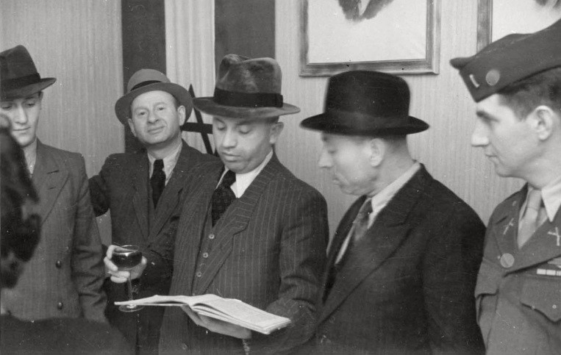

Reprinted from the website of Hidabroot.com

The 5 Most Important Things To Know About Passover
By Rabbi Benjamin Blech

Our greatest contributions to the world summarized in five words: memory, optimism, faith, family, and responsibility.

Scholars have long wondered why Jews who number less than one quarter of one percent of the world – as Milton Himmelfarb memorably put it, "The total population of the Jewish people is less than a statistical error in the annual birth rate of the Chinese people” – have had such a profound influence on almost every field of human endeavor.
What accounts for the remarkable fact that in the 20th century, Jews, more than any other minority, have been recipients of the Nobel Prize, with almost one-fifth of all Nobel laureates being Jewish?
Perhaps it all goes back to the very beginning of the birth of our people and the Passover holiday that we will shortly be celebrating.
Passover conveys five major concepts that became our mantras for how to lead successful and productive lives. They are the five most important things to know about Passover, and to incorporate into every day of the rest of the year. Because we’ve absorbed them into our national psyche for the thousands of years since the Exodus, we’ve been privileged to fulfill in great measure our prophetically mandated role to become a light unto the nations.
They are our greatest contributions to the world and can be summarized in five words: memory, optimism, faith, family, and responsibility.

The Importance of Memory
The Irish Catholic writer Thomas Cahill was so overwhelmed by how the Jewish people literally transformed the world that he authored what proved to become an international bestseller, The Gifts of the Jews. One of the major gifts he credits to Jewish genius is the invention of the idea of history.
"Remember that you were strangers in the land of Egypt." "Remember that the Lord took you out of the bondage of slavery." Remember is a biblical mandate that had never seemed important to anyone else before the Jewish people came on the scene. It was the Passover story that initiated a commitment to memory.
Henry Ford was famous for his belief that "history is bunk." The Ford motor company is also famous for producing the Edsel. And both were probably equally stupid blunders. History is the only way we can learn from the past. History allows us to grow by standing on the shoulders of giants. Make a mistake once, and you’re human. Never learn from what happened before, and you’re brainless. That's why it's so important to heed the famous words of George Santayana that "Those who do not learn from the past are condemned to repeat it."
Memory links our past to our future. It turns history into destiny.
We know how horrible it can be to live without a personal memory of events that preceded. For an individual we have a name for it that fills us with terror: Alzheimer's. It is a disease we fear perhaps even more than death because it leaves us living corpses. Strangely enough, we don't have a similar word for the condition that describes ignorance of our collective past. Knowing what came before is almost as important in an historic sense as it is in a personal one. Only by being aware of our past as a people can our lives become filled with purpose and meaning.
Memory links our past to our future. It turns history into destiny. Learning to treasure it was the first step in our climb up the ladder of greatness.

The Importance of Optimism
To study the Passover story in depth is to recognize that the most difficult task Moses had to perform was not to get the Jews out of Egypt, but to get Egypt out of the Jews. They had become so habituated to their status as slaves, they lost all hope that they could ever improve their lot.
Without hope they would have been lost.
The true miracle of Passover and its relevance for the ages is the message that with G-d’s help, no difficulty is insurmountable. A tyrant like Pharaoh could be overthrown. A nation as powerful as Egypt could be defeated. Slaves could become freemen. The oppressed could break the shackles of their captivity. Anything is possible, if only we dare to dream the impossible dream.
In the story of America's Great Seal, a particularly relevant chapter is the imagery suggested by Benjamin Franklin in August 1776. He chose the dramatic scene described in Exodus, where people confronted a tyrant in order to gain their freedom.
"Pharaoh sitting in an open Chariot, a Crown on his head and a Sword in his hand, passing through the divided Waters of the Red Sea in Pursuit of the Israelites: Rays from a Pillar of Fire in the Cloud, expressive of the Divine Presence and Command, beaming on Moses who stands on the shore and extending his hand over the Sea causes it to overwhelm Pharaoh."
The motto he suggested, words based on the Passover story, inspired George Washington and the founding fathers of the American colonies to rebel against their British oppressors: “Rebellion to Tyrants is Obedience to G-d."
It was the biblical record of the Exodus that enabled the spirit of optimism to prevail for the followers of Martin Luther King in their quest for equal rights, because they were stirred by the vision of Moses leading his people to the Promised Land. It was the hope engendered by recalling how G-d redeemed our ancestors that allowed even Jews incarcerated in Auschwitz to furtively celebrate the Festival of Freedom and believe in the possibility of their own liberation.
That optimistic spirit, based on our own miraculous history, is the second great gift we have given to mankind and defines our identity.

The Importance of Faith
A pessimist, it's been said, is someone who has no invisible means of support.
Jewish optimism is rooted in a contrary notion, a firmly held belief that we are blessed with support from above by a caring G-d. And that faith in a personal God gives us faith in ourselves, in our future and in our ability to help change the world
The G-d of Sinai didn't say "I am the Lord your G-d who created the heavens and the earth." Instead, he announced, "I am the Lord your G-d who took you out of the land of Egypt, the house of bondage." The G-d of creation could theoretically have forsaken the world once he completed his task. The G-d of the Exodus made clear He is constantly involved in our history and has a commitment to our survival.
The Passover story conveys that history is not happenstance. It follows a Divine master plan.
Thomas Cahill credits the Jews not only for monotheism but for this additional groundbreaking idea of a Divine being with Whom we share a personal relationship. This, he points out, is key to Western civilization’s concept of personal accountability, conscience and culpability for ourselves and the rest of the world.
The Passover story conveys that history is not happenstance. It follows a Divine master plan. It has a predestined order. “Order” in Hebrew is “Seder” – and that is why the major ritual of Passover is identified by that name. Coincidence is not a Jewish concept. Coincidence is just G-d's way of choosing to remain anonymous.
Faith gives us the certainty that whatever our present-day problems, history moves in the direction of the final messianic redemption. That is what has always motivated us to believe in progress and to participate in tikkun olam, efforts to improve the world.

The Importance of Family
Passover taught us yet another major truth: the way to perfect the world is to begin with our own families.
G-d built His nation by commanding not a collective gathering of hundreds of thousands in a public square but by asking Jews to turn their homes into places of family worship at a Seder devoted primarily to answering the questions of children.
It seems all too obvious. Children are our future. They are the ones who most require our attention. The home is where we first form our identities and discover our values.
More even than the synagogue, it is in our homes that we sow the seeds of the future and ensure our continuity. No wonder then that commentators point out the very first letter of the Torah is a bet, the letter whose meaning is house. All of the Torah follows only after we understand the primacy of family.
The world may mock Jewish parents for their over-protectiveness and their child-centered way of life, but they are the ones chiefly responsible for the extraordinary achievements of their progeny.
At the Seder table, the children are encouraged to be the stars and their questions are treated with respect. And that is the first step to developing Jewish genius.

The Importance of Responsibility to Others
One serious question begs to be asked as we celebrate our Divine deliverance from the slavery of Egypt. We thank G-d for getting us out, but why did God allow us to become victims of such terrible mistreatment in the first place?
A remarkable answer becomes evident in numerous Torah texts. We were slaves in Egypt – and so we have to have empathy for the downtrodden in every generation. We were slaves in Egypt – and so we have to be concerned with the rights of the strangers, the homeless and the impoverished. We experienced oppression – and so we must understand more than anyone else the pain of the oppressed.
The tragedy of our encounter with injustice was in no small measure meant to prepare us to serve throughout all future generations as spokesman for those with whose pain we can personally identify.
The purpose of our suffering was to turn us into a people committed to righting the wrongs of the world, to become partners with G-d in making the world worthy of final redemption.
We begin the Seder by inviting the hungry and the homeless to join with us. We conclude the Seder by opening the door for Elijah. It is our acceptance of responsibility to others that is the key to hastening the arrival of Messiah.
From earliest childhood every Jew identifies with these five powerful ideas that are at the heart of Passover and its message. And precisely because memory, optimism, faith, family and responsibility have become such vital characteristics of our people, we have been able to achieve far beyond what anyone might have considered possible.

Reprinted from the website of Aish.com

A Yemenite Seder in Israel - 1960
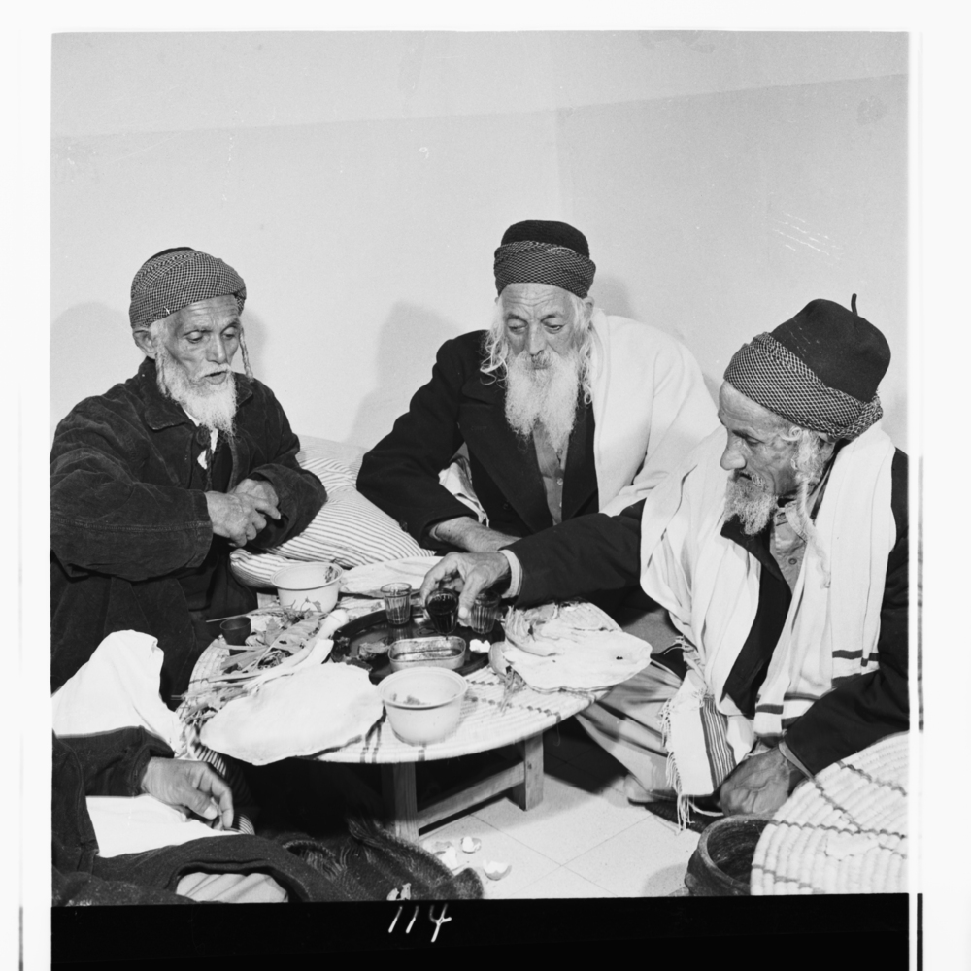

Yemeni Jews celebrate the Passover seder at a Joint Distribution Committee Home for Seniors. Shaar-Menashe, Israel, 1960

Reprinted from the April 22, 2014 website of the Huffington Post.
IDF on Full Alert for Pesach

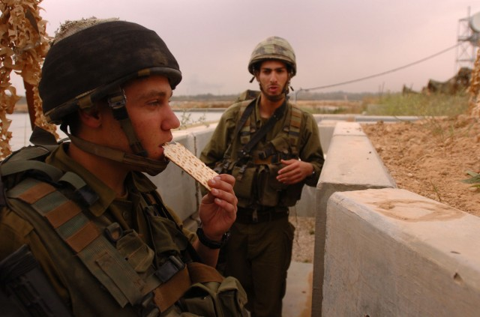

The IDF is making preparations to celebrate the holiday of Passover, which commemorates the ancient Israelites’ exodus from slavery in Egypt. Although Jewish people worldwide will be celebrating Passover with friends and family, many IDF soldiers will not able to do so because IDF Chief of Staff Benny Gantz has ordered all IDF units to cancel their usual Passover vacation.
All IDF units are expected to remain on full alert due to unspecified security threats, possibly from Gaza. Israel has previously come under attack during Jewish holidays, including the 1973 Yom Kippur war and the terrorist attack during Passover in 2002.

Reprinted from the April 6, 2012 website of the Algemeiner Journal.

